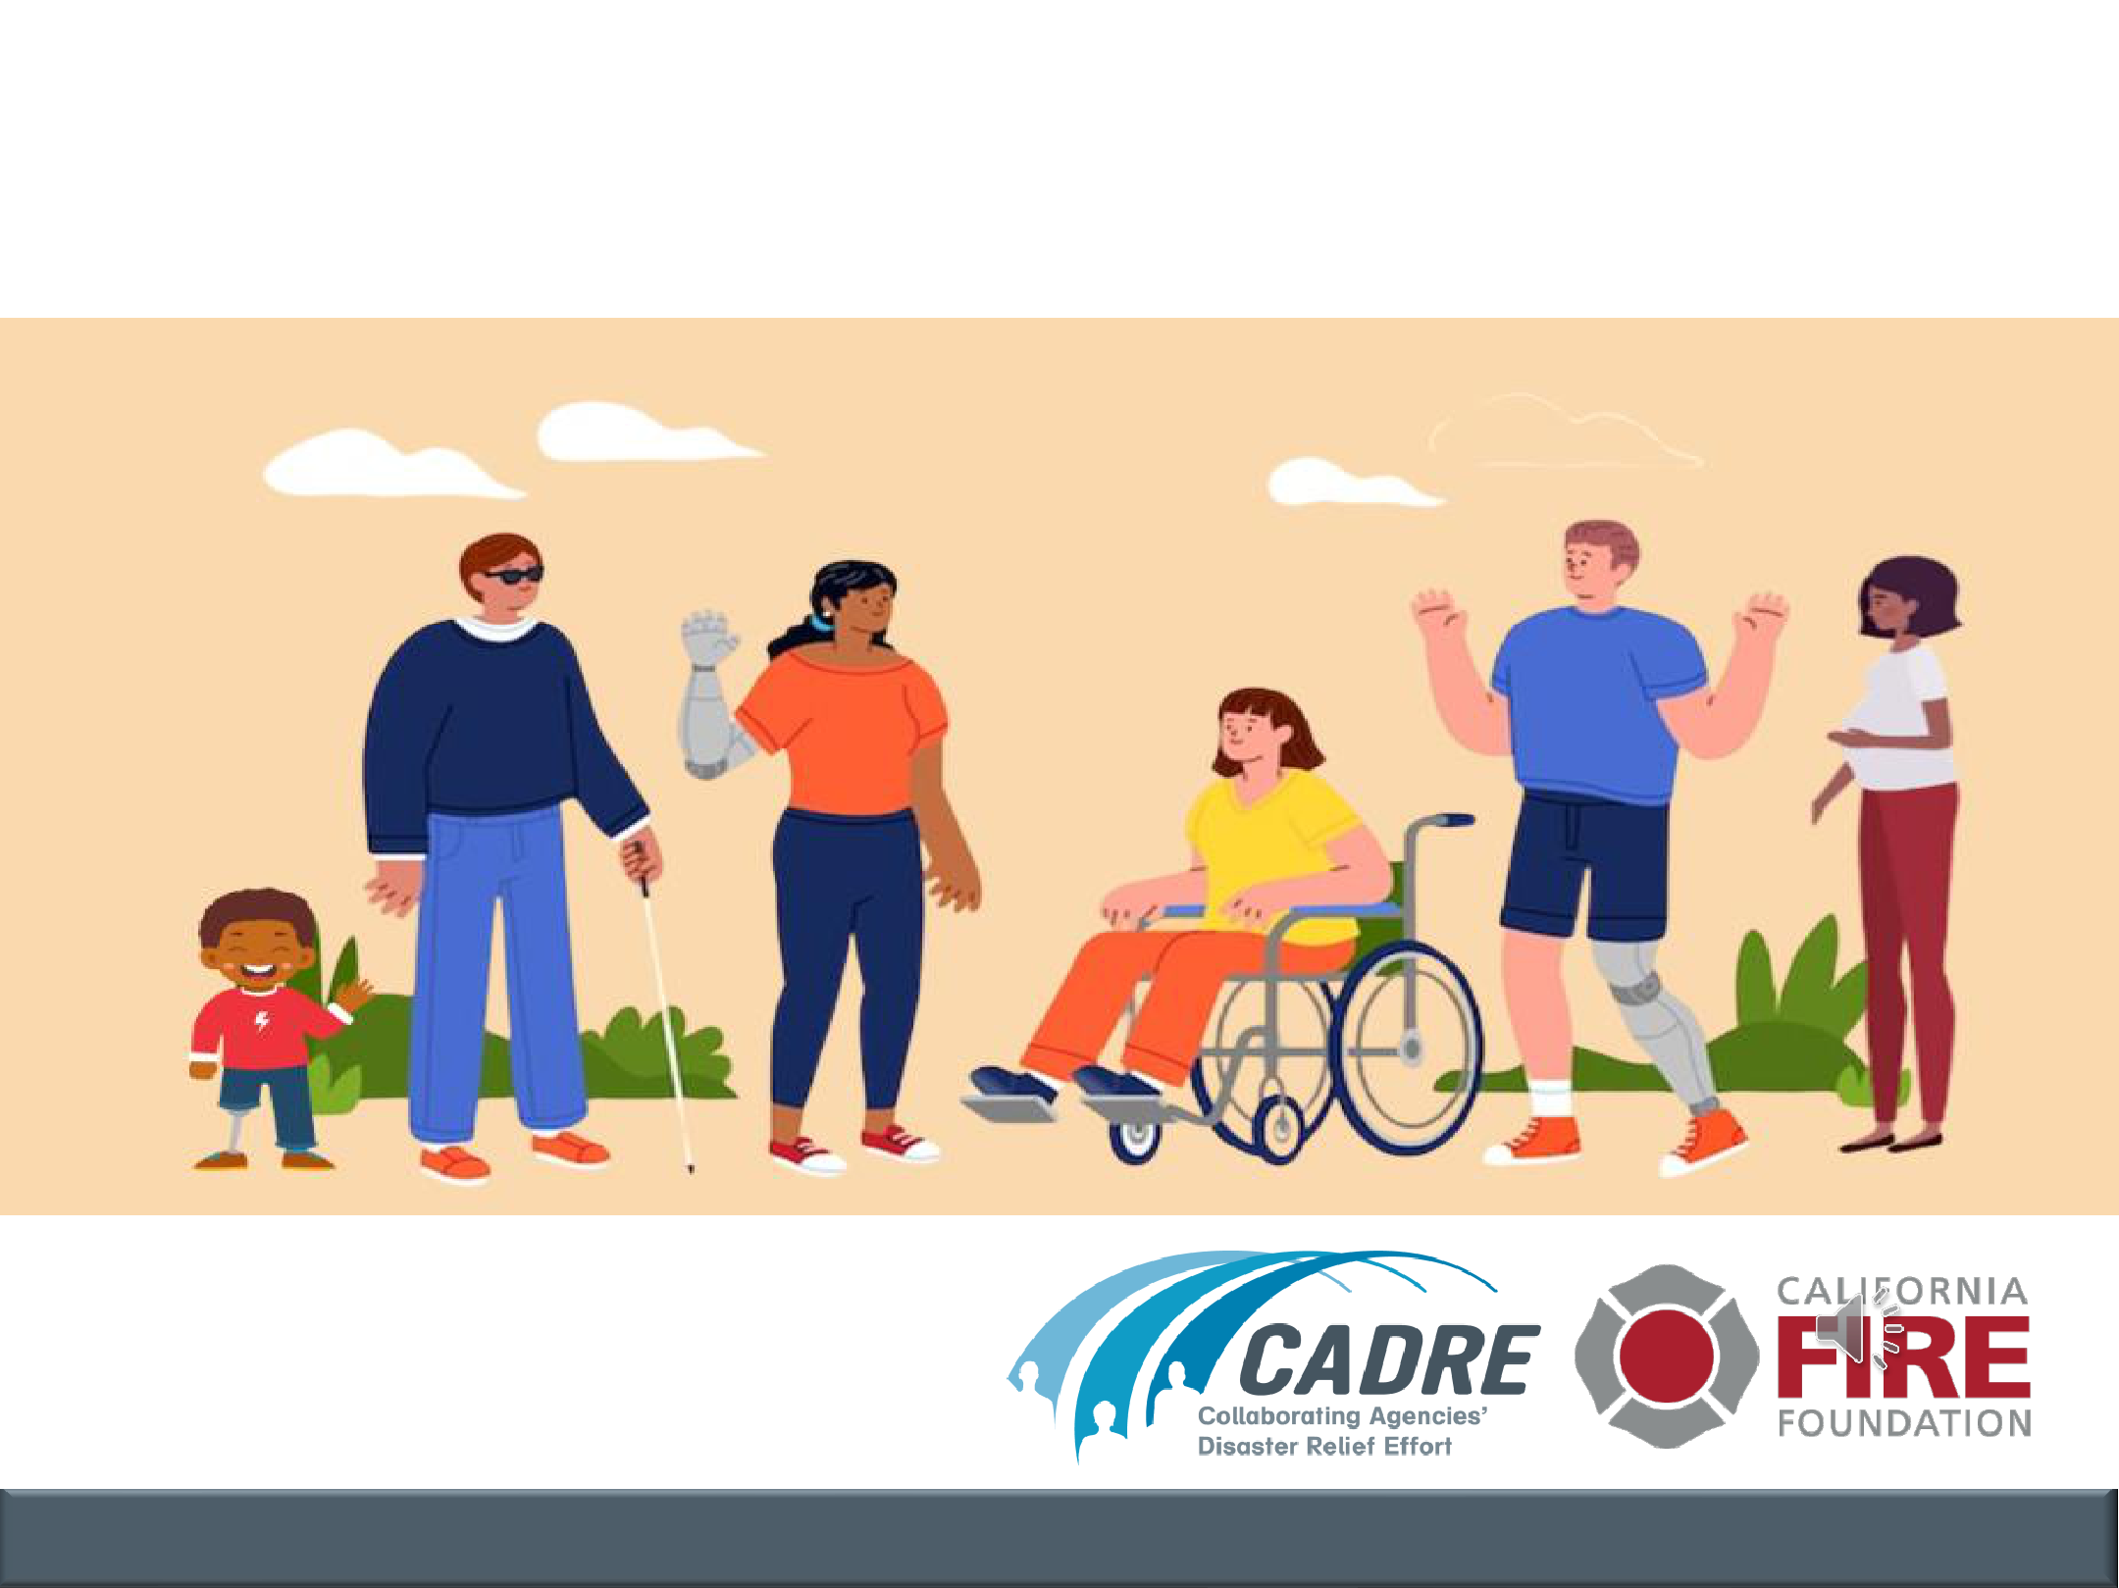
Disaster Preparedness for those

with disabilities

Brought to you by:

COMMUNICATION | COLLABORATION | COORDINATION | COOPERATION

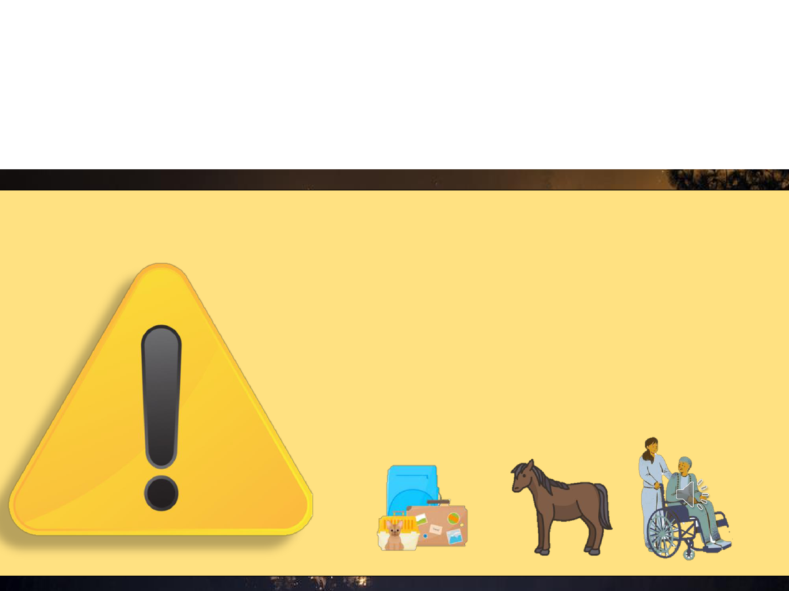
Leave at the first sign of danger, don’t wait for an alert!

EVACUATION WARNING:

Get ready to evacuate. Leave now if you need extra time!

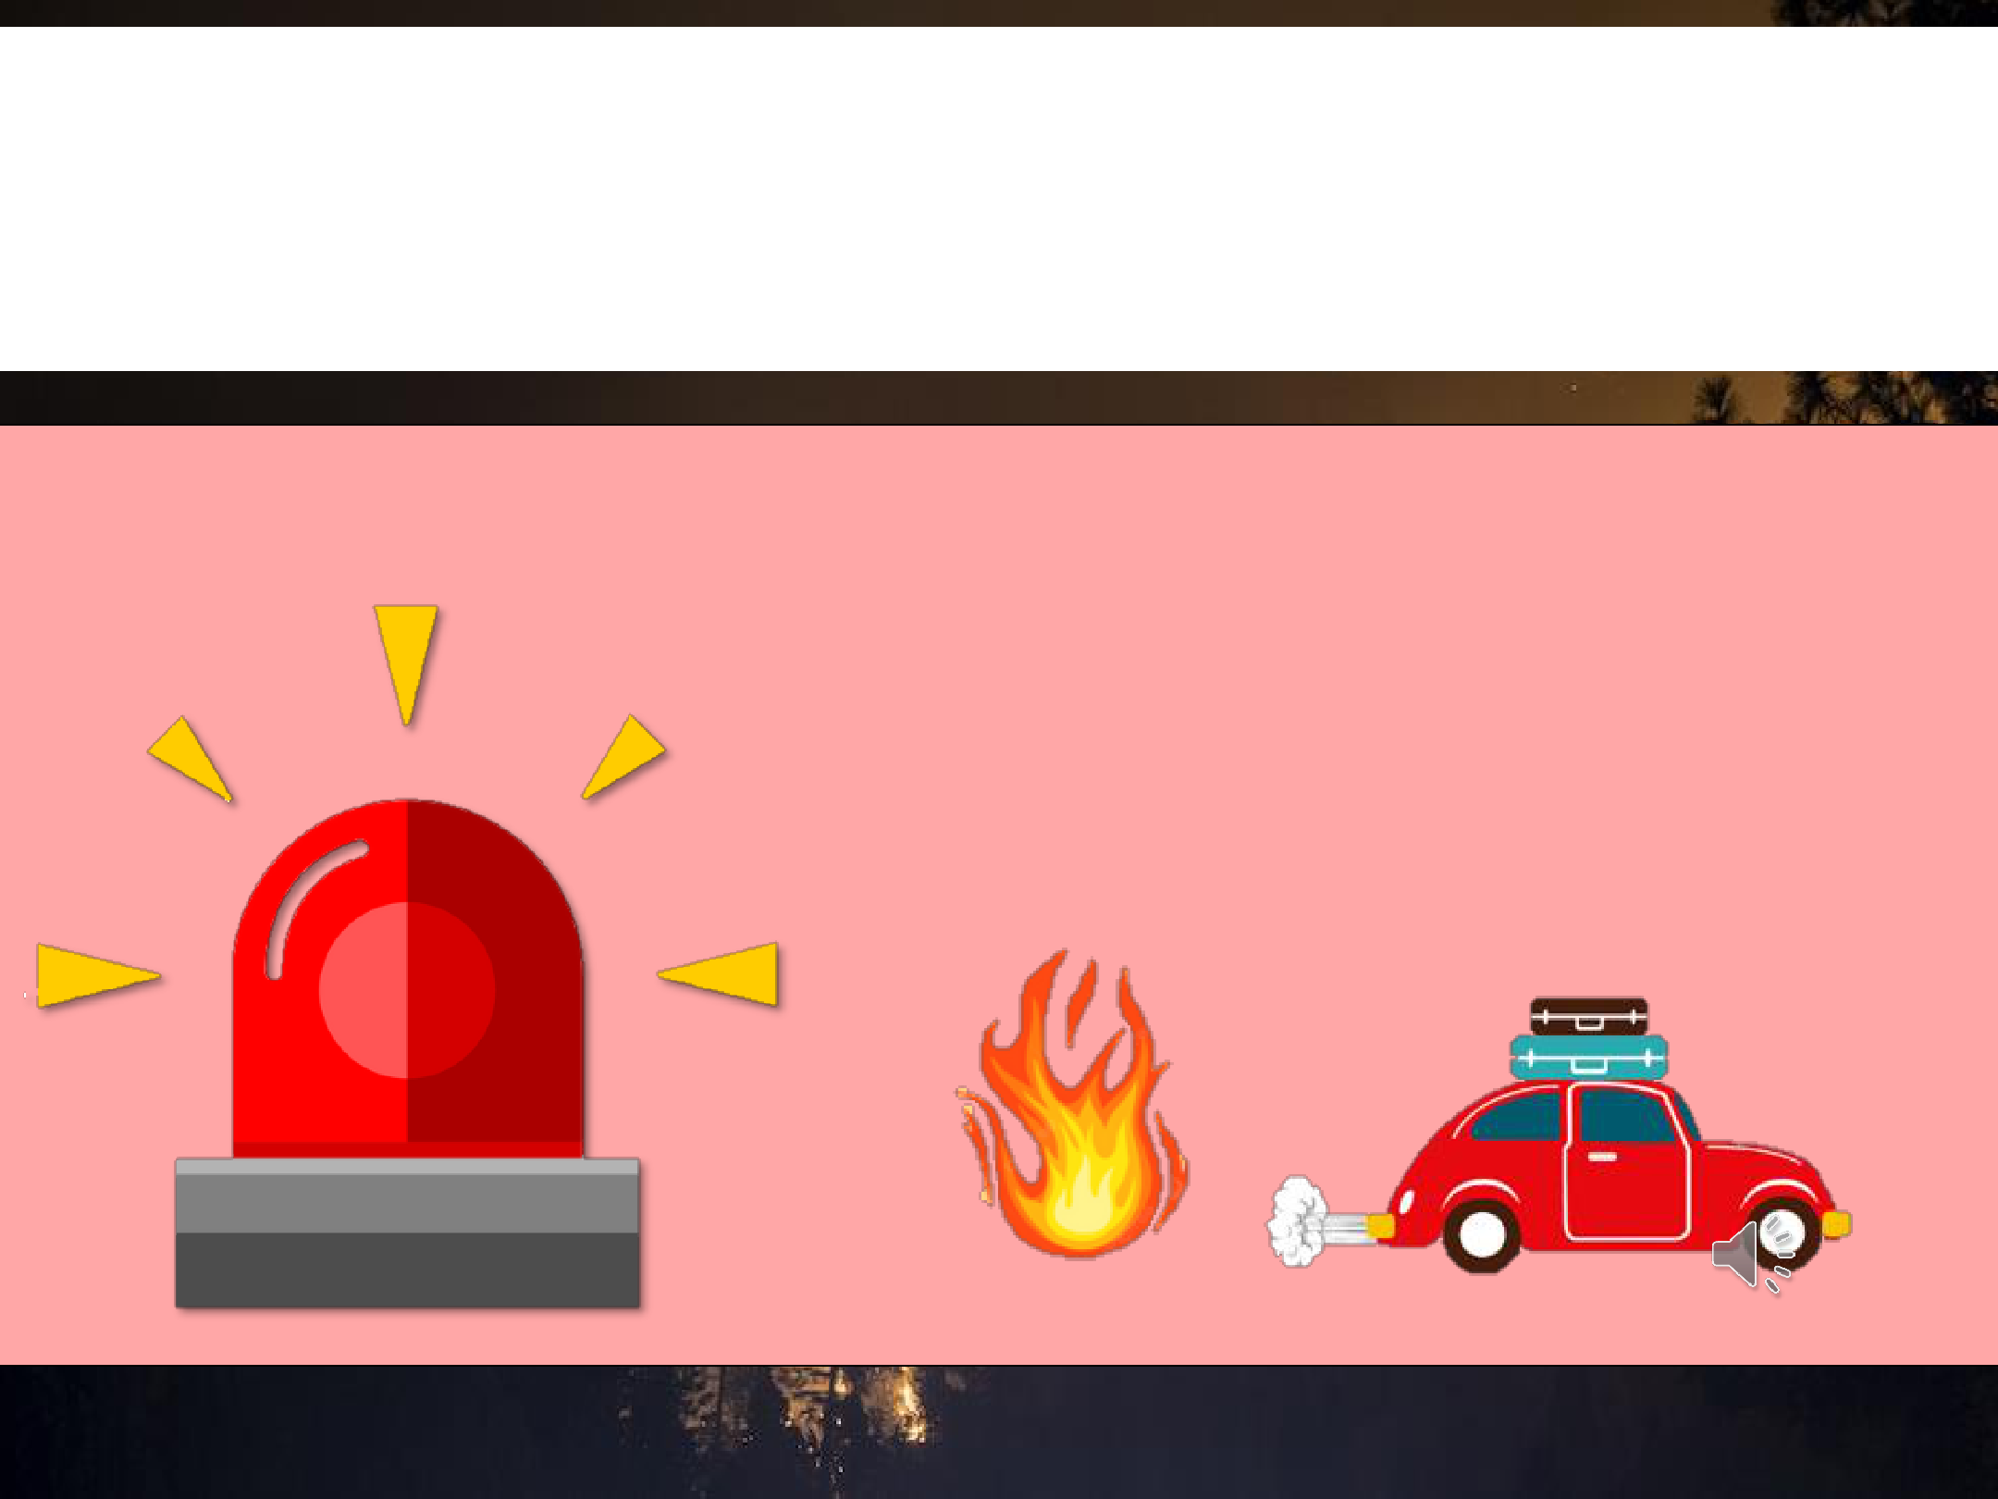
Leave at the first sign of danger, don’t wait for an alert!

EVACUATION ORDER:

Get out now!

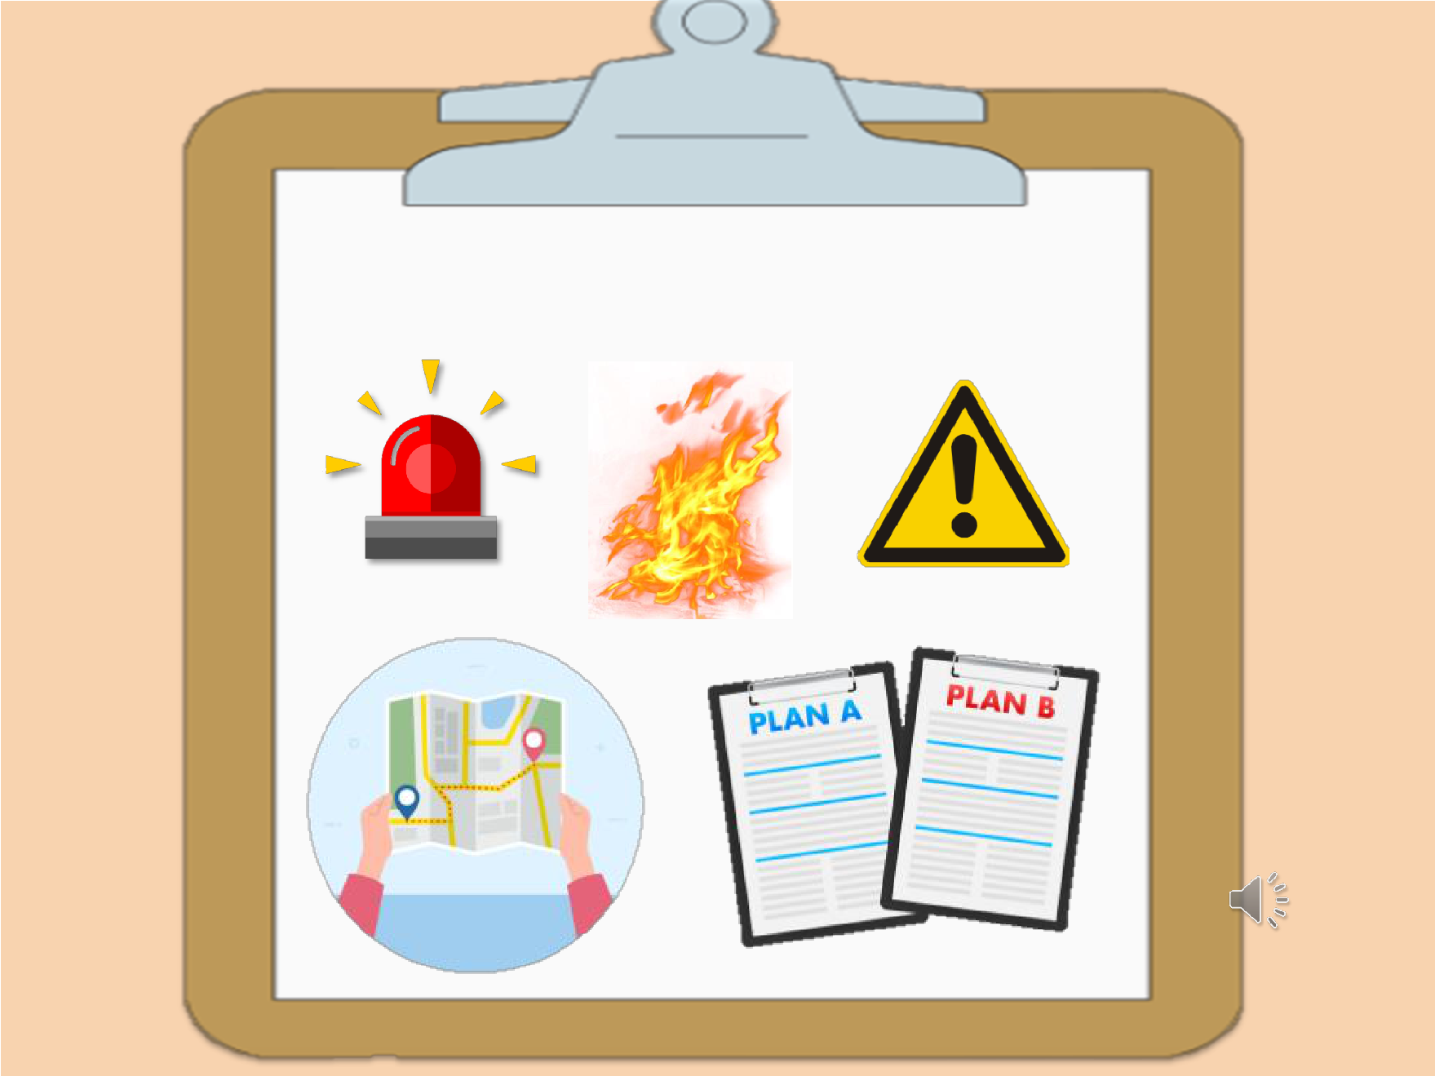

EMERGENCY PLAN

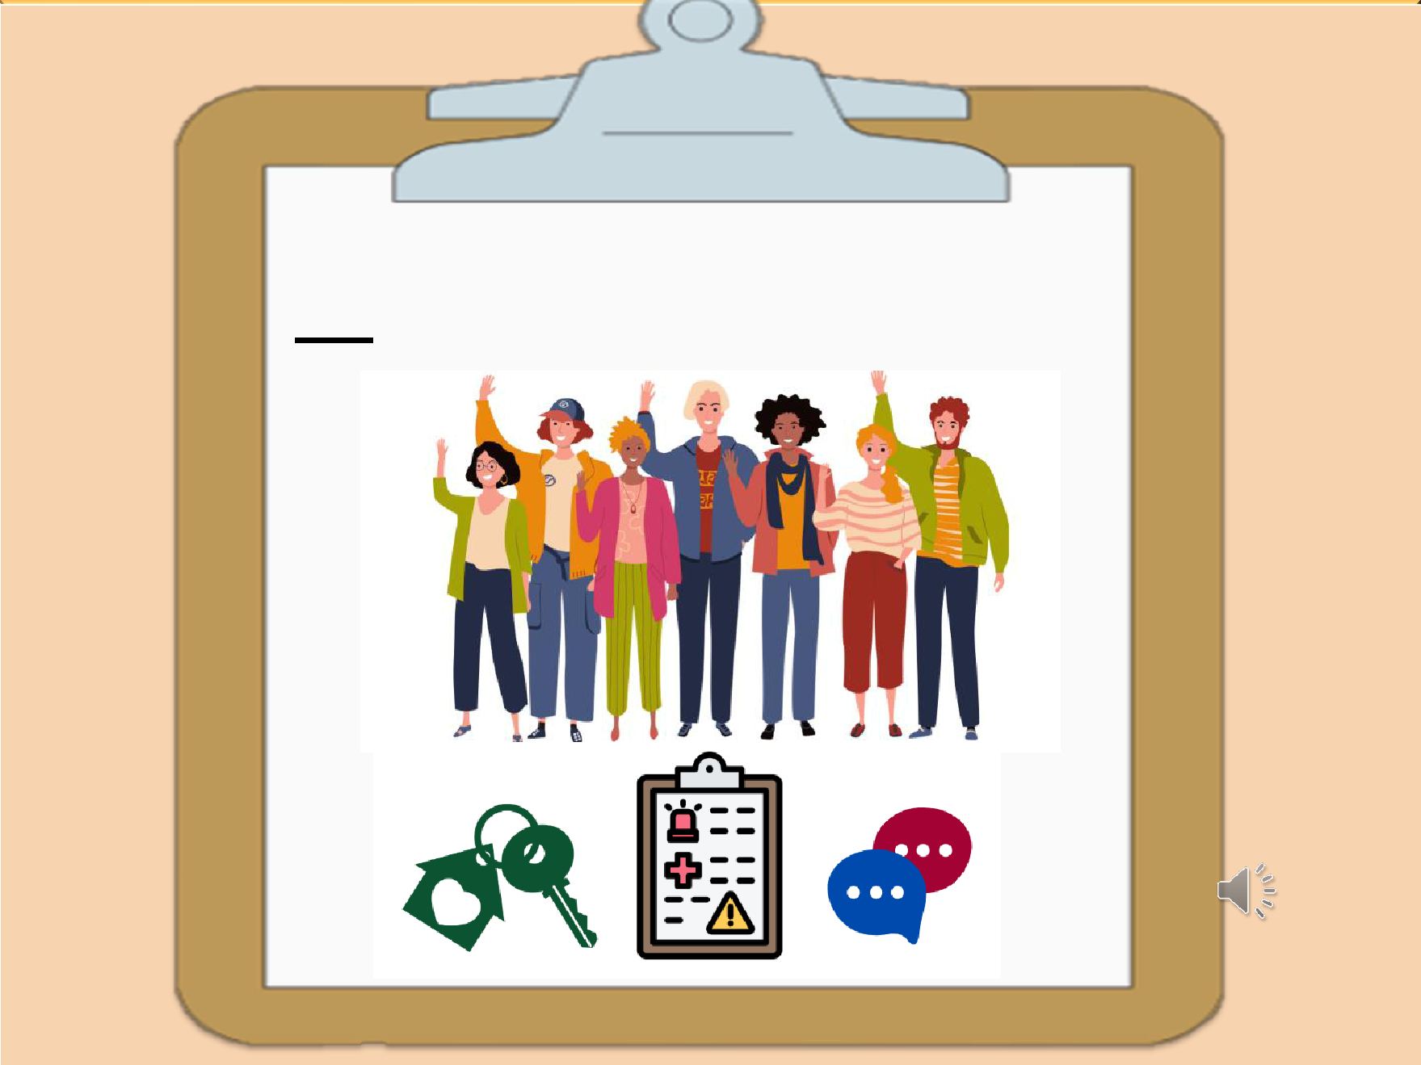

Support Network

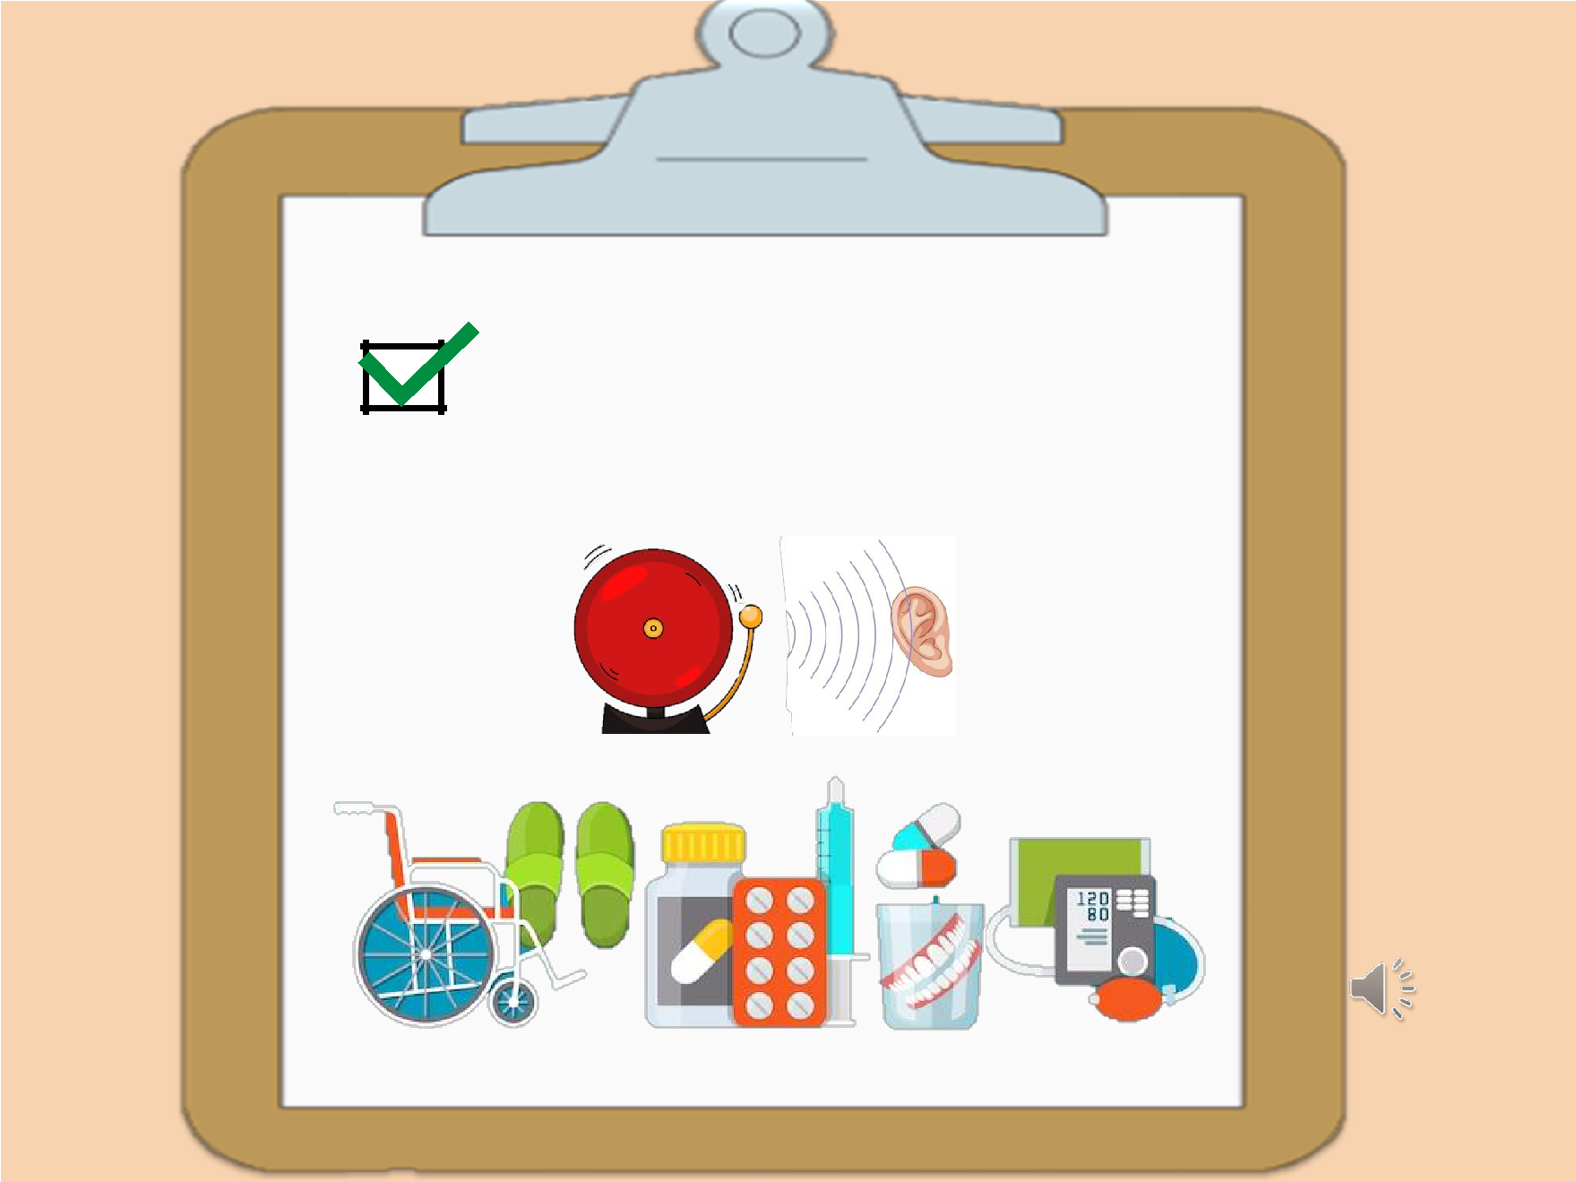

Medical supplies and services

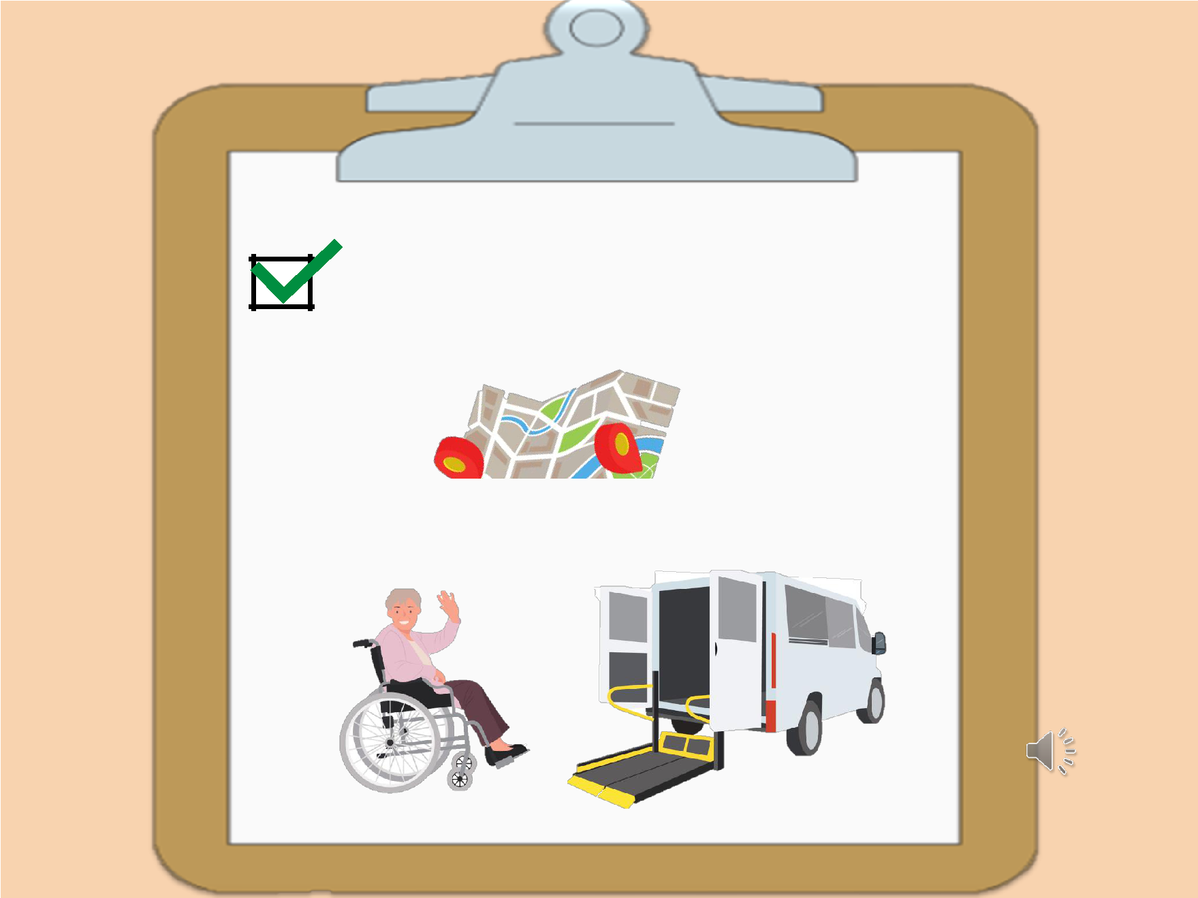

How and where to evacuate

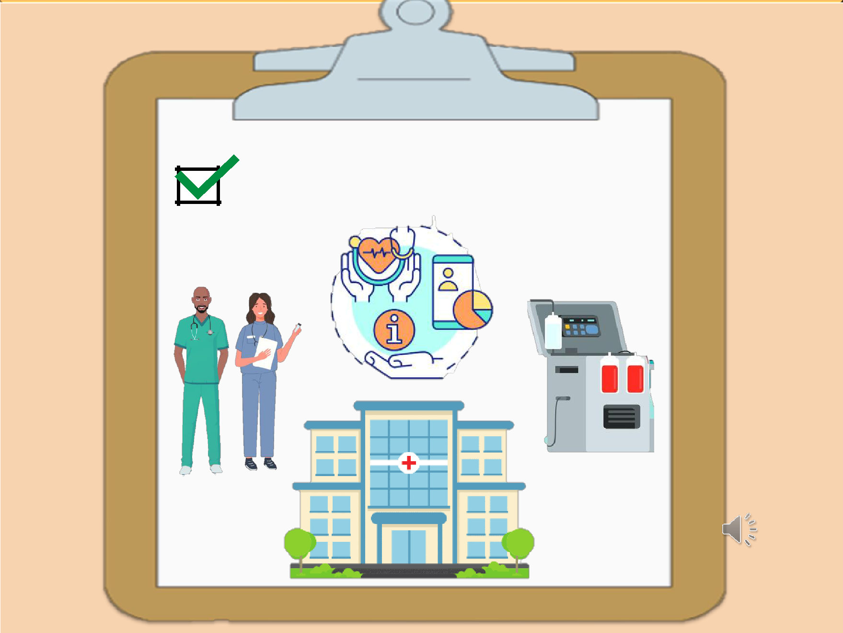

Service providers

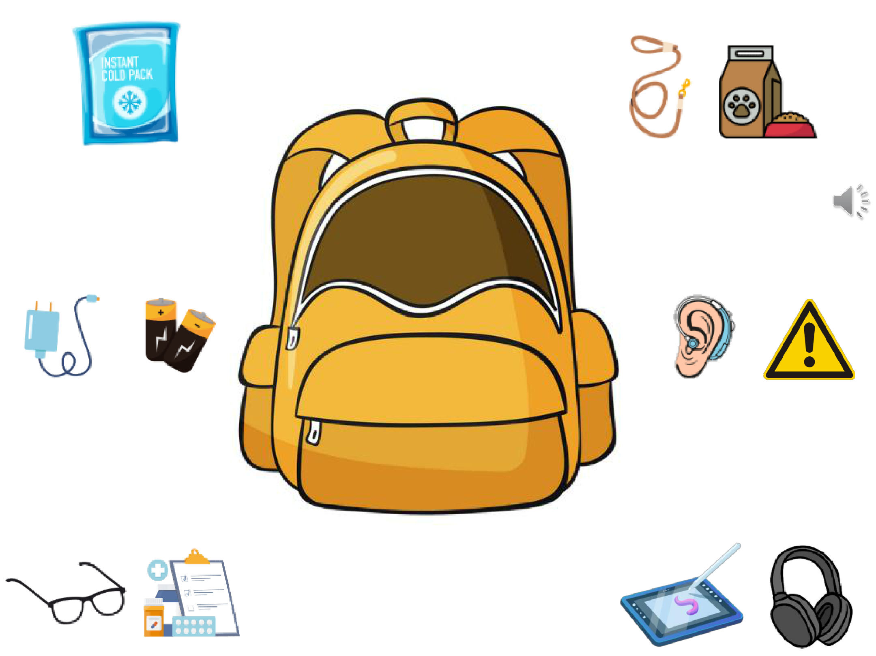

EMERGENCY KIT

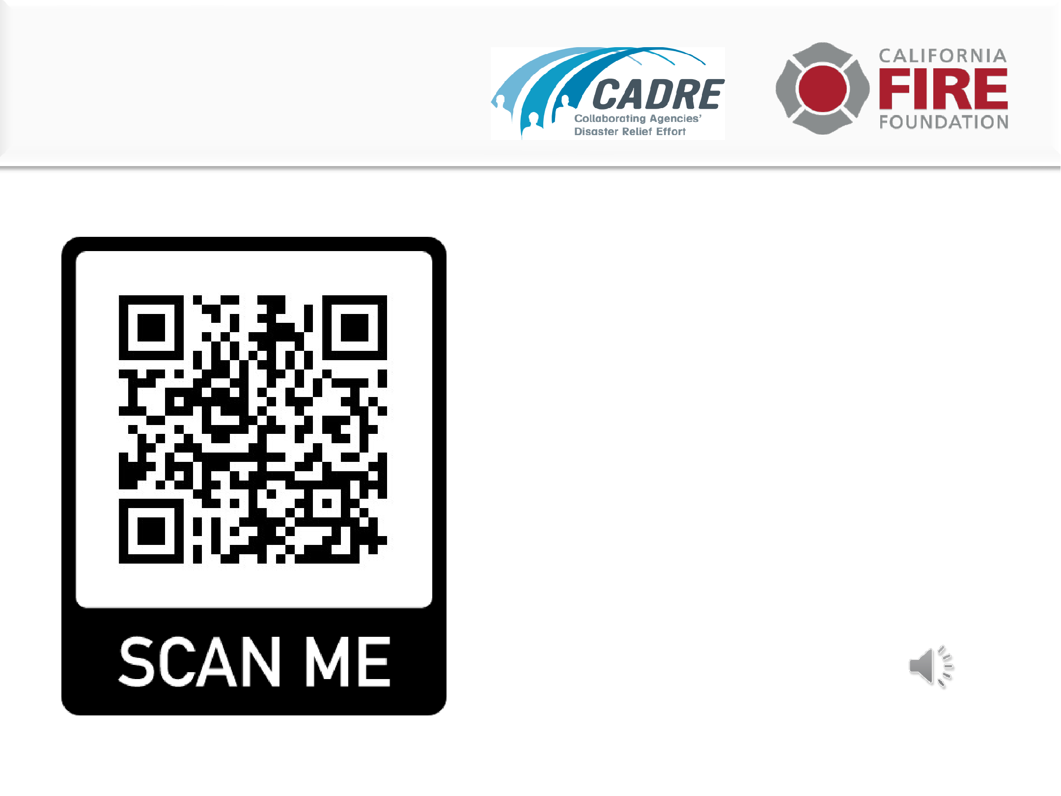
Brought to you by

Learn more

www.cadresv

.org/wildfire

