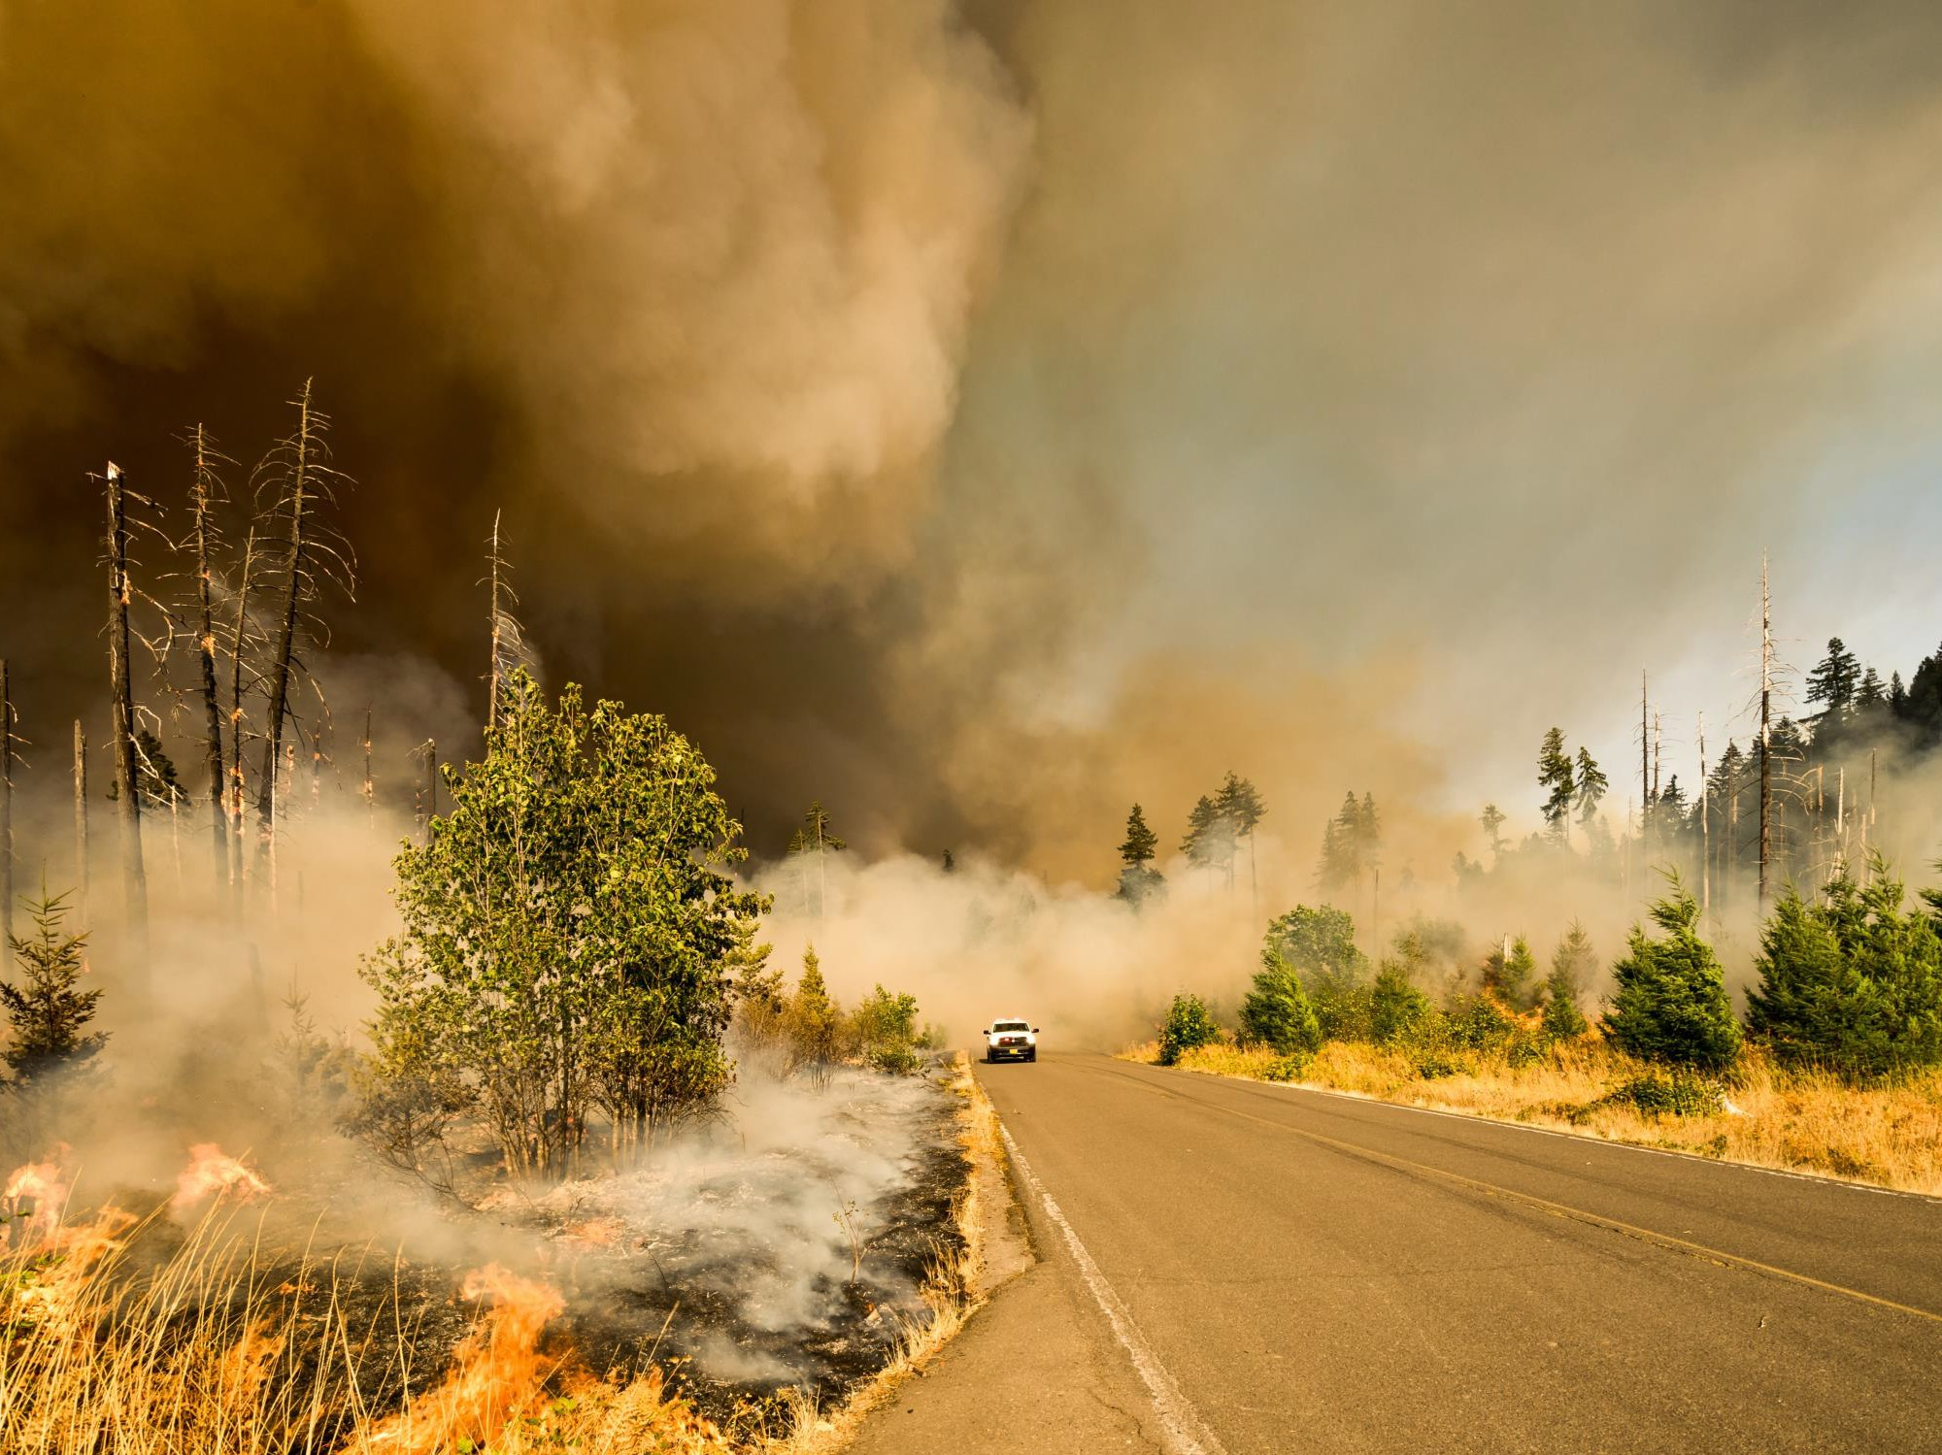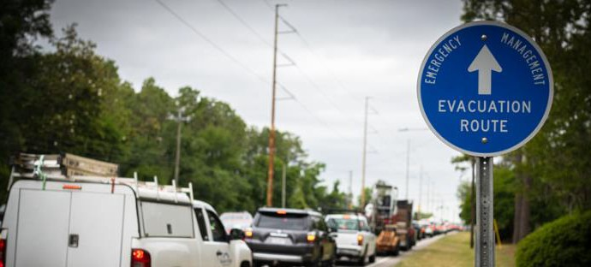

**What to Expect During Evacuations**

**Brought to you by:**

COMMUNICATION | COLLABORATION | COORDINATION | COOPERATION

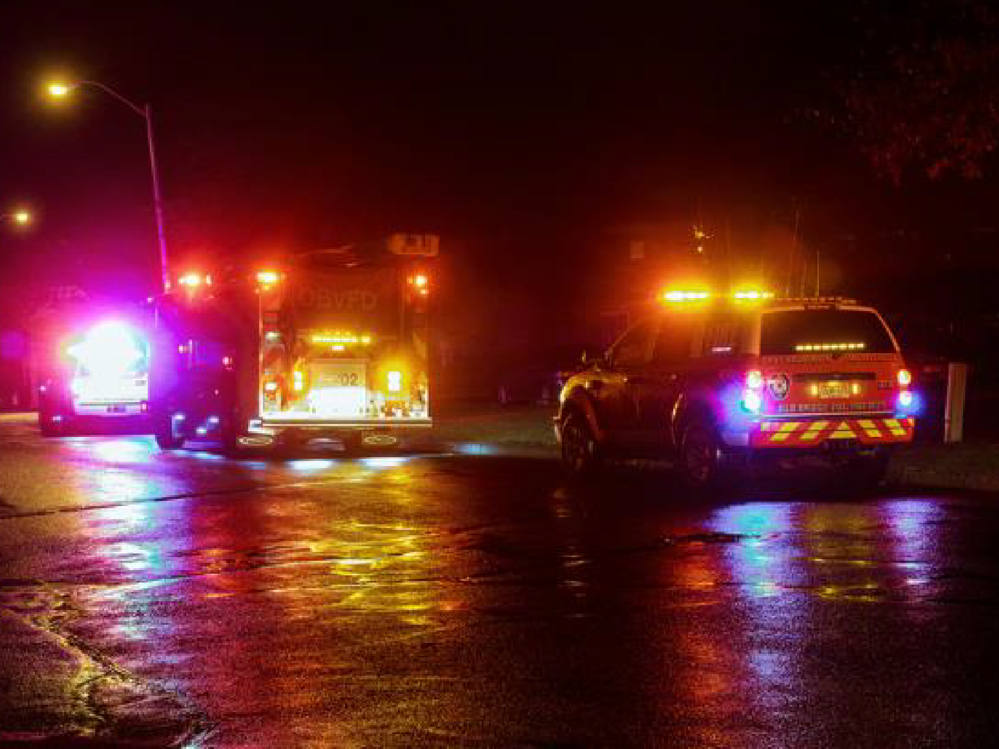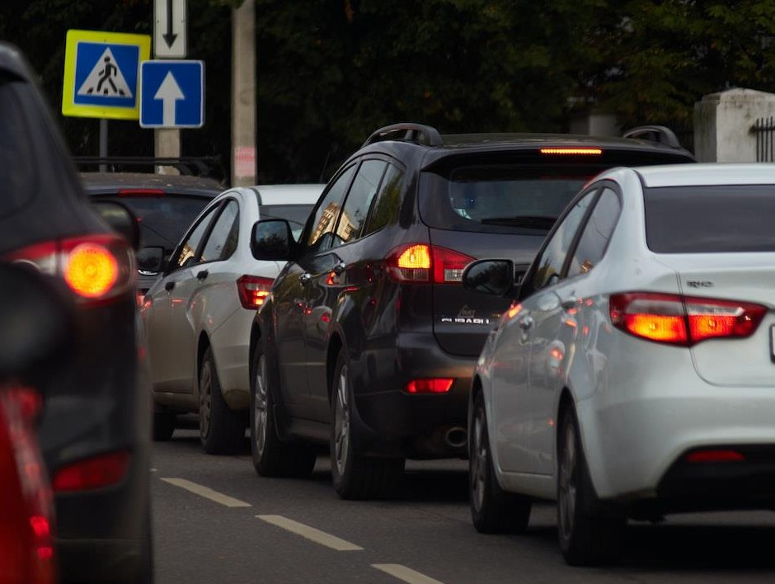

COMMUNICATION | COLLABORATION | COORDINATION | COOPERATION

# ✓CARPOOL

**DURING EVACUATIONS**

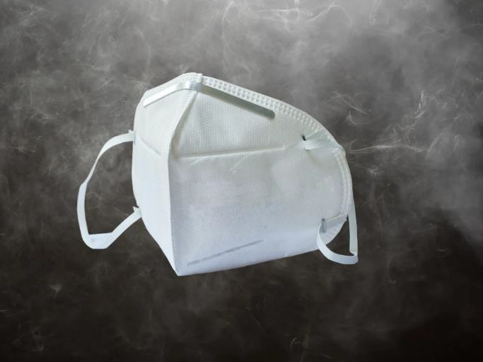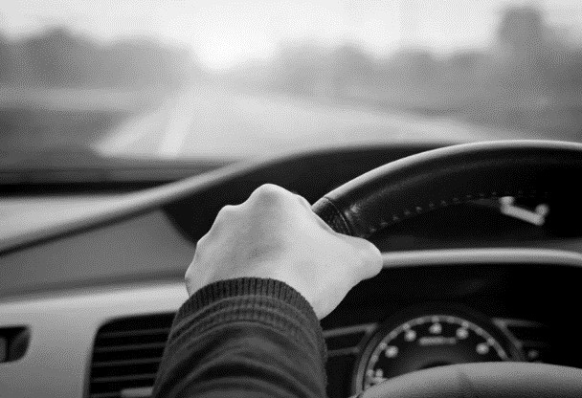

* **DRIVE CAUTIOUSLY**

COMMUNICATION | COLLABORATION | COORDINATION | COOPERATION

COMMUNICATION | COLLABORATION | COORDINATION | COOPERATION

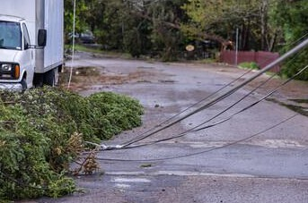

# DO NOT DRIVE OVER DOWNED WIRES

✓**OUT OF AREA CALLS**

COMMUNICATION | COLLABORATION | COORDINATION | COOPERATION



✓**TEXT**

✓**Cash in hand**

COMMUNICATION | COLLABORATION | COORDINATION | COOPERATION



* **Gas tank at least halfway full**

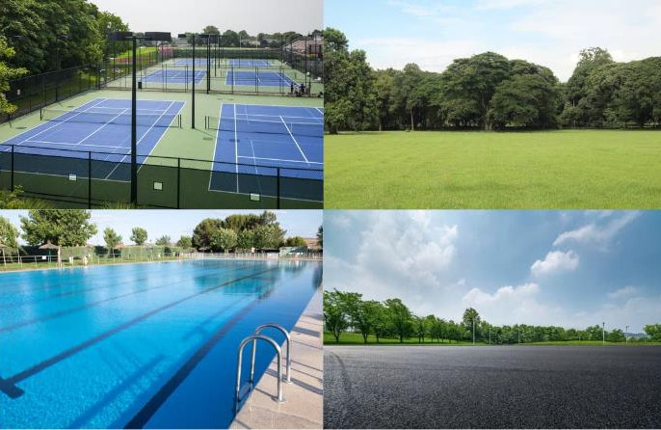

**IF TRAPPED**



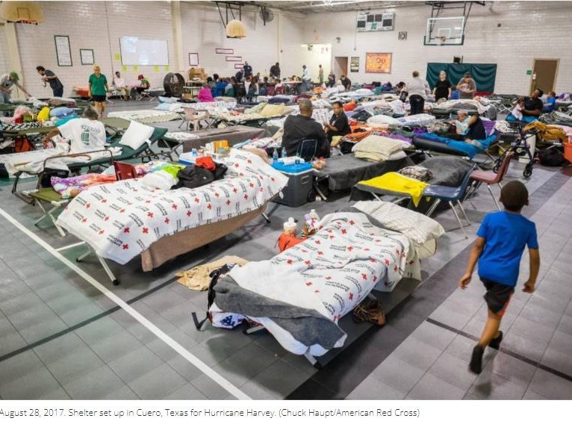

**ONCE EVACUATED**

utsch 日本語 Tiếng

العربية

Français

Русский

中国人

Ελληνικά

Tagalog

De

**ASK FOR A TRANSLATOR**

Việt Nam

English

조선말

ትግርኛ

Español

國語



ह िंदी

**YOU HAVE A RIGHT TO RECEIVE DISASTER AID:**

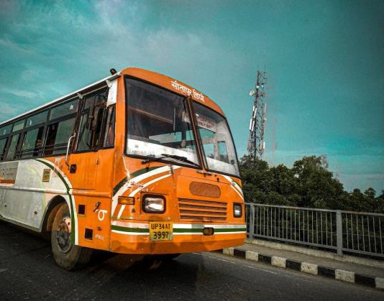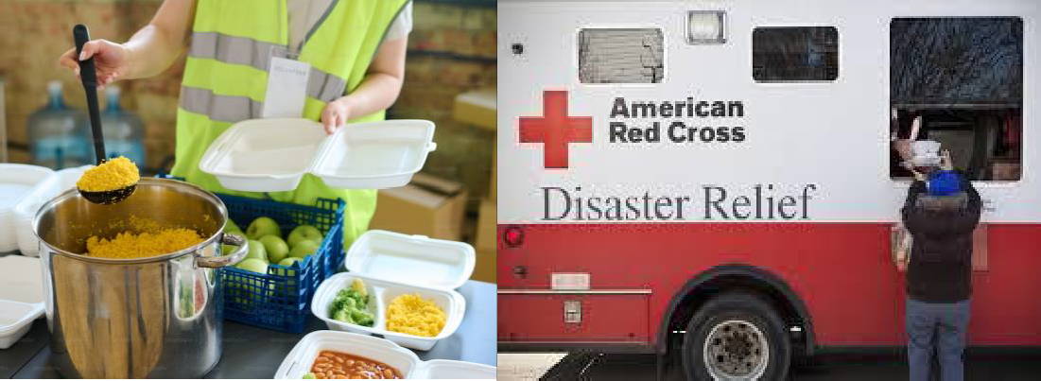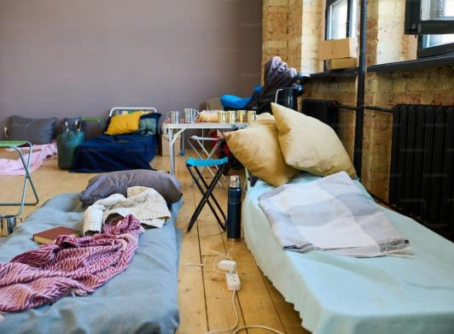

REGARDLESS OF IMMIGRATION STATUS AND WITHOUT PROOF OF IDENTIFICATION



**Brought to you by**

Learn more: www.cadresv



.org/wildfire

