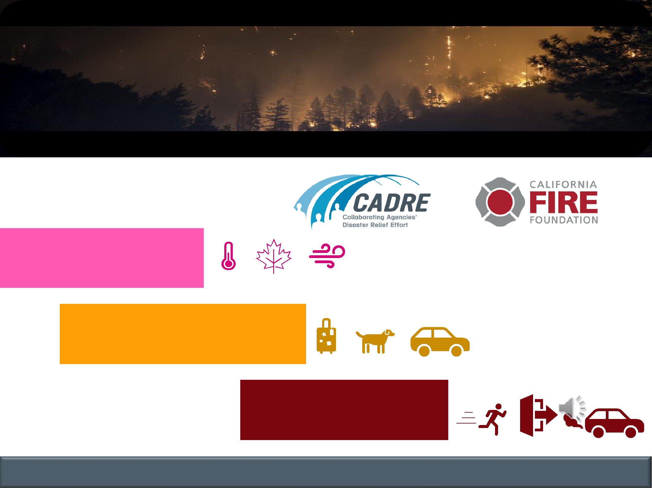
Wildfire Evacuation

Terminology and Response

Brought to you by:

RED FLAG

WARNING

EVACUATION

WARNING

EVACUATION

ORDER

COMMUNICATION | COLLABORATION | COORDINATION | COOPERATION

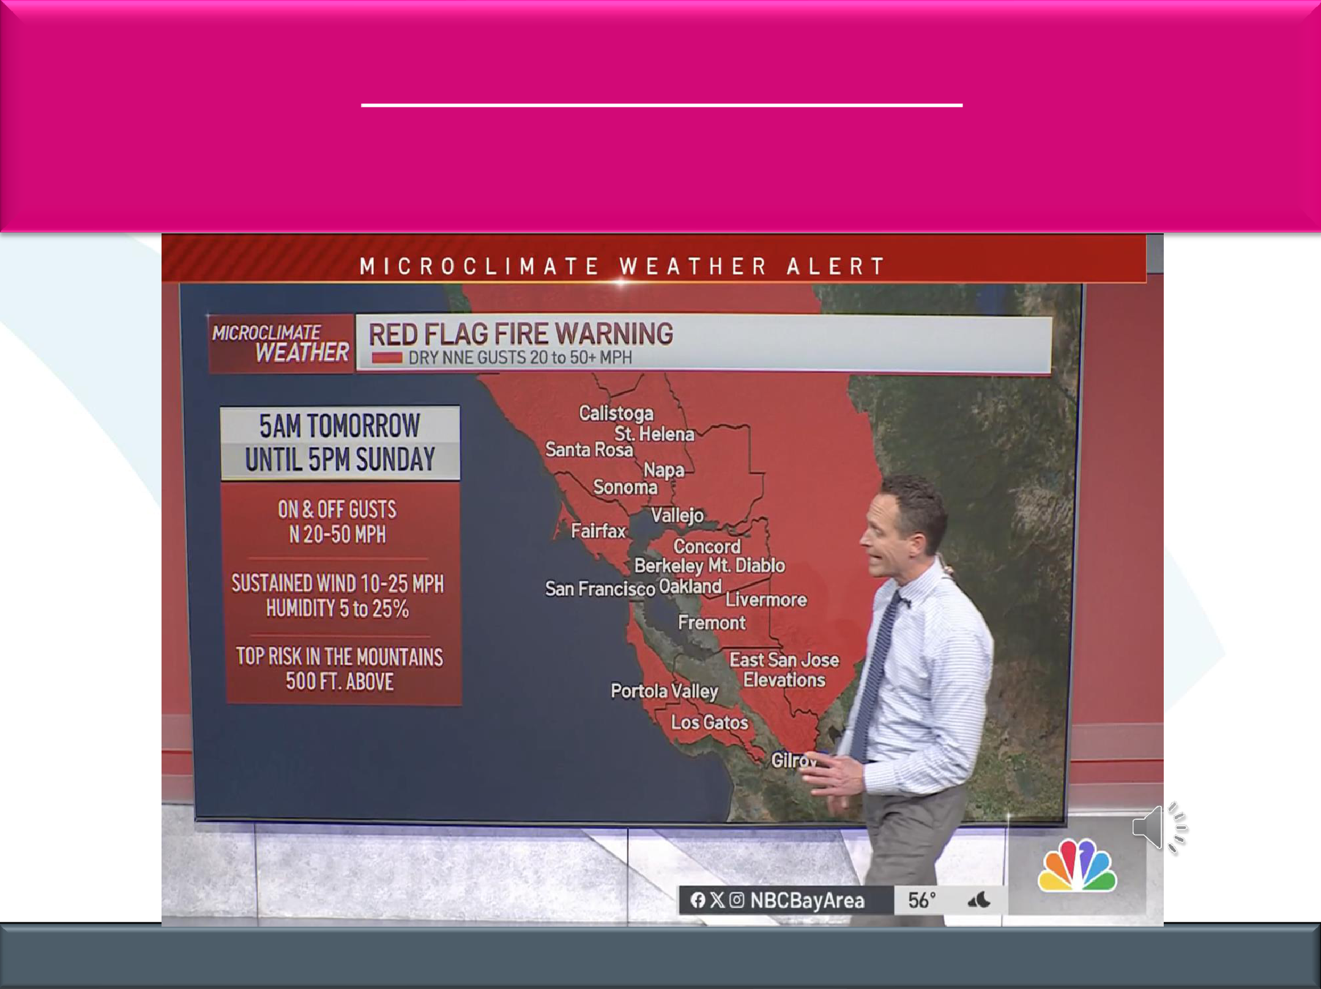
RED FLAG WARNING

Fire conditions (dry, hot, windy) are occurring or will occur.

COMMUNICATION | COLLABORATION | COORDINATION | COOPERATION

RED FLAG WARNING

Phone Number: 408-808-7871 | QR Code:

Email: noreply@everbridge.net

Website: AlertSCC.com

COMMUNICATION | COLLABORATION | COORDINATION | COOPERATION

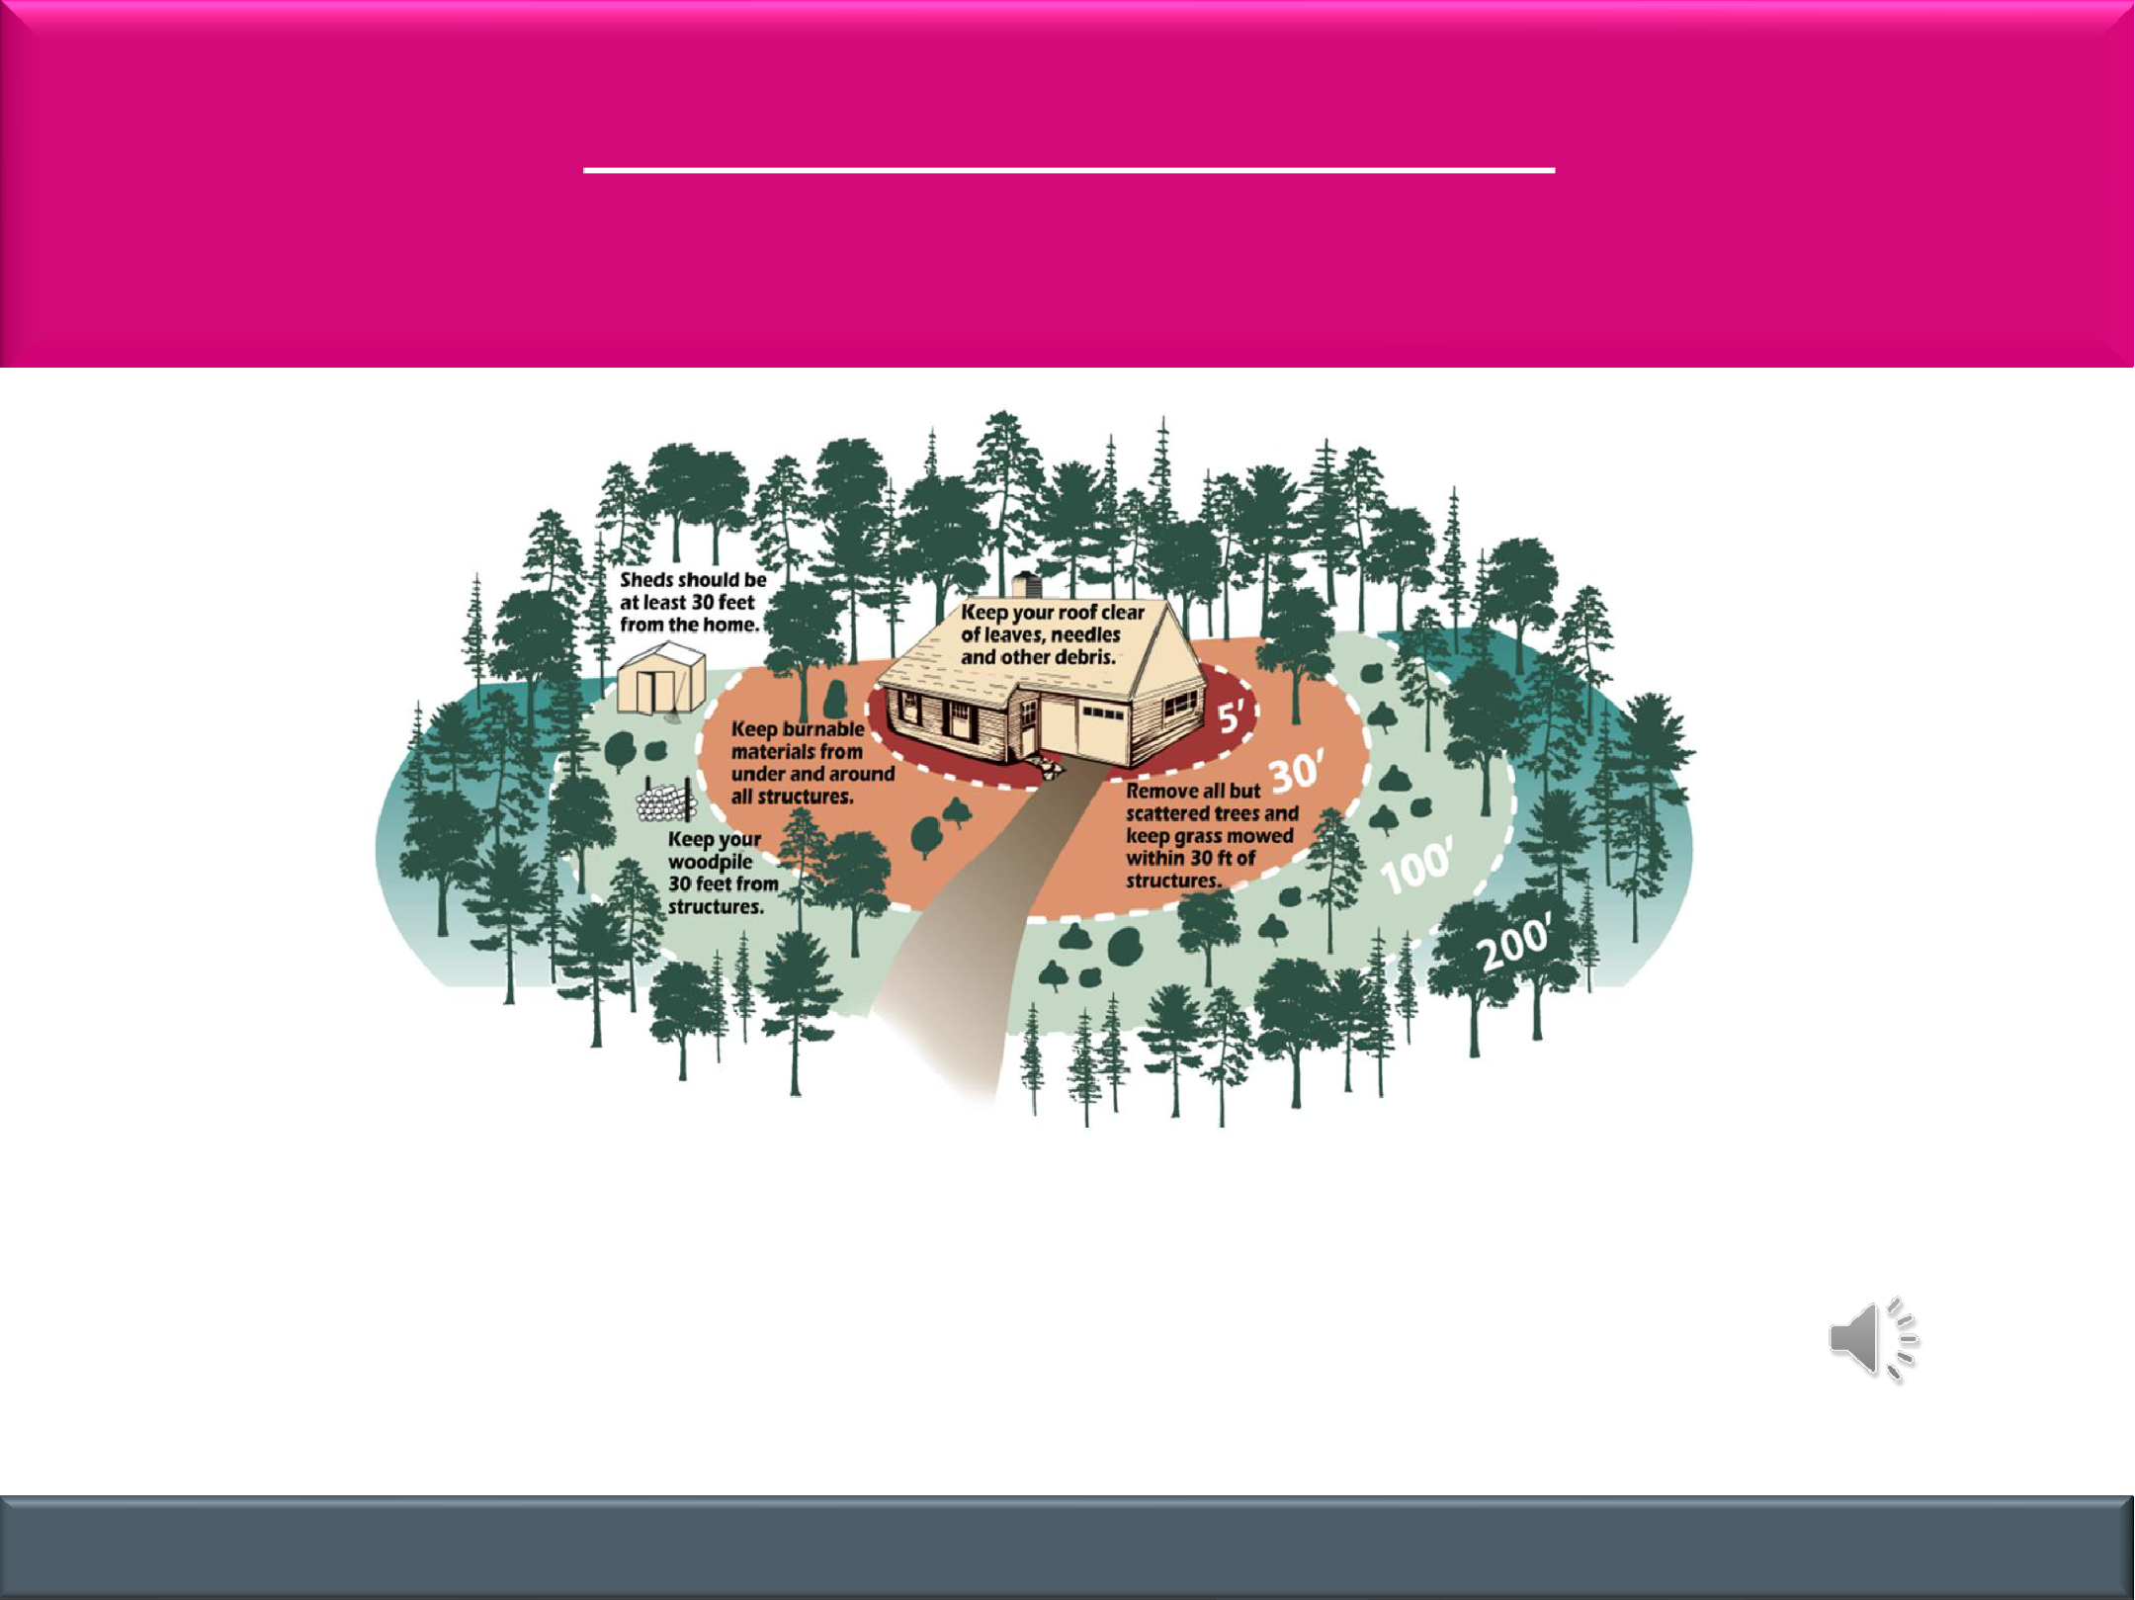
RED FLAG WARNING

Remove burnable items near your home.

✓Keep your roof clear of leaves, needles and other debris
✓Keep burnable materials from under and around structures

✓Remove all but scattered trees and keep grass mowed within 30’ of structures
✓Keep your woodpile 30 feet from structures
✓Sheds should be at least 30 feet from the home.

COMMUNICATION | COLLABORATION | COORDINATION | COOPERATION

RED FLAG WARNING

Be ready to go!

- Check with your city to learn about evacuation plans and where to go.

- Make/Review your own emergency plans & supply kits.

- Check local news and government websites for weather updates.

✓ Keep phone volume turned up.

COMMUNICATION | COLLABORATION | COORDINATION | COOPERATION

EVACUATION WARNING

Fire is close.

LEAVE NOW IF YOU NEED EXTRA TIME TO EVACUATE

BE PREPARED TO EVACUATE

COMMUNICATION | COLLABORATION | COORDINATION | COOPERATION

COMMUNICATION | COLLABORATION | COORDINATION | COOPERATION

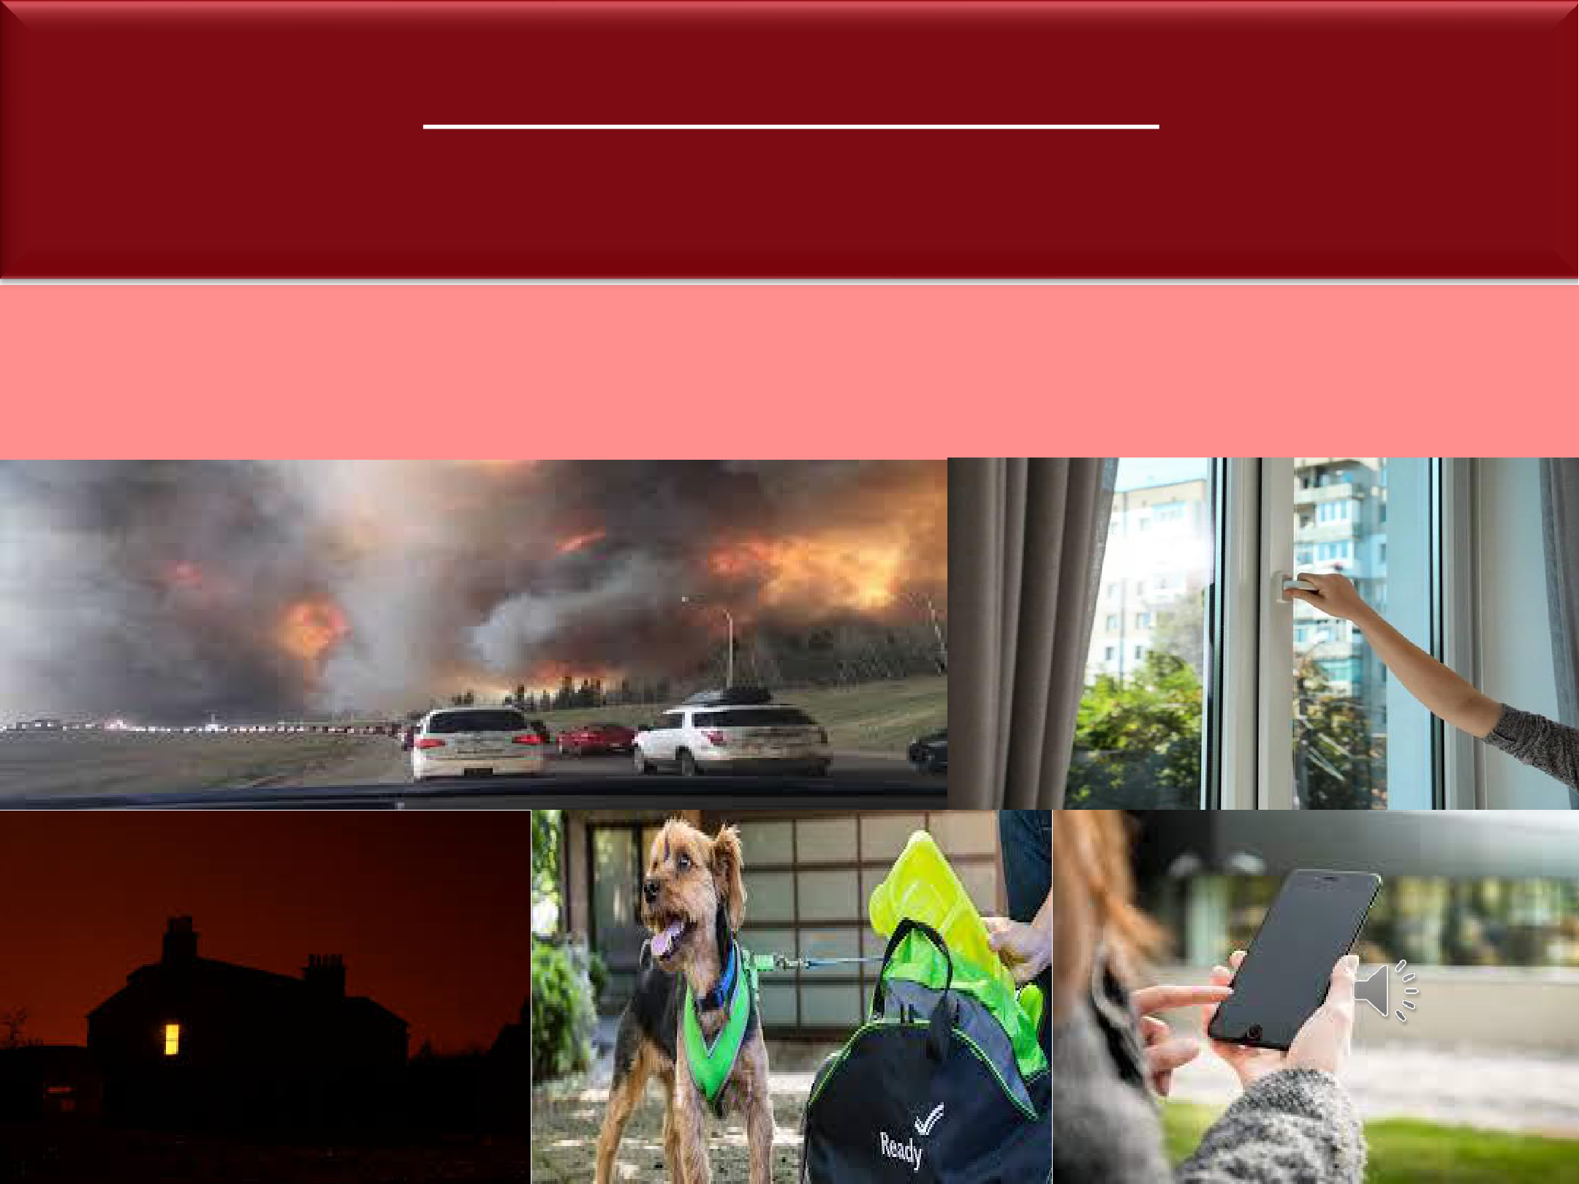
EVACUATION ORDER

Fire is here, you are in danger

YOU ARE OUT OF TIME, LEAVE NOW!

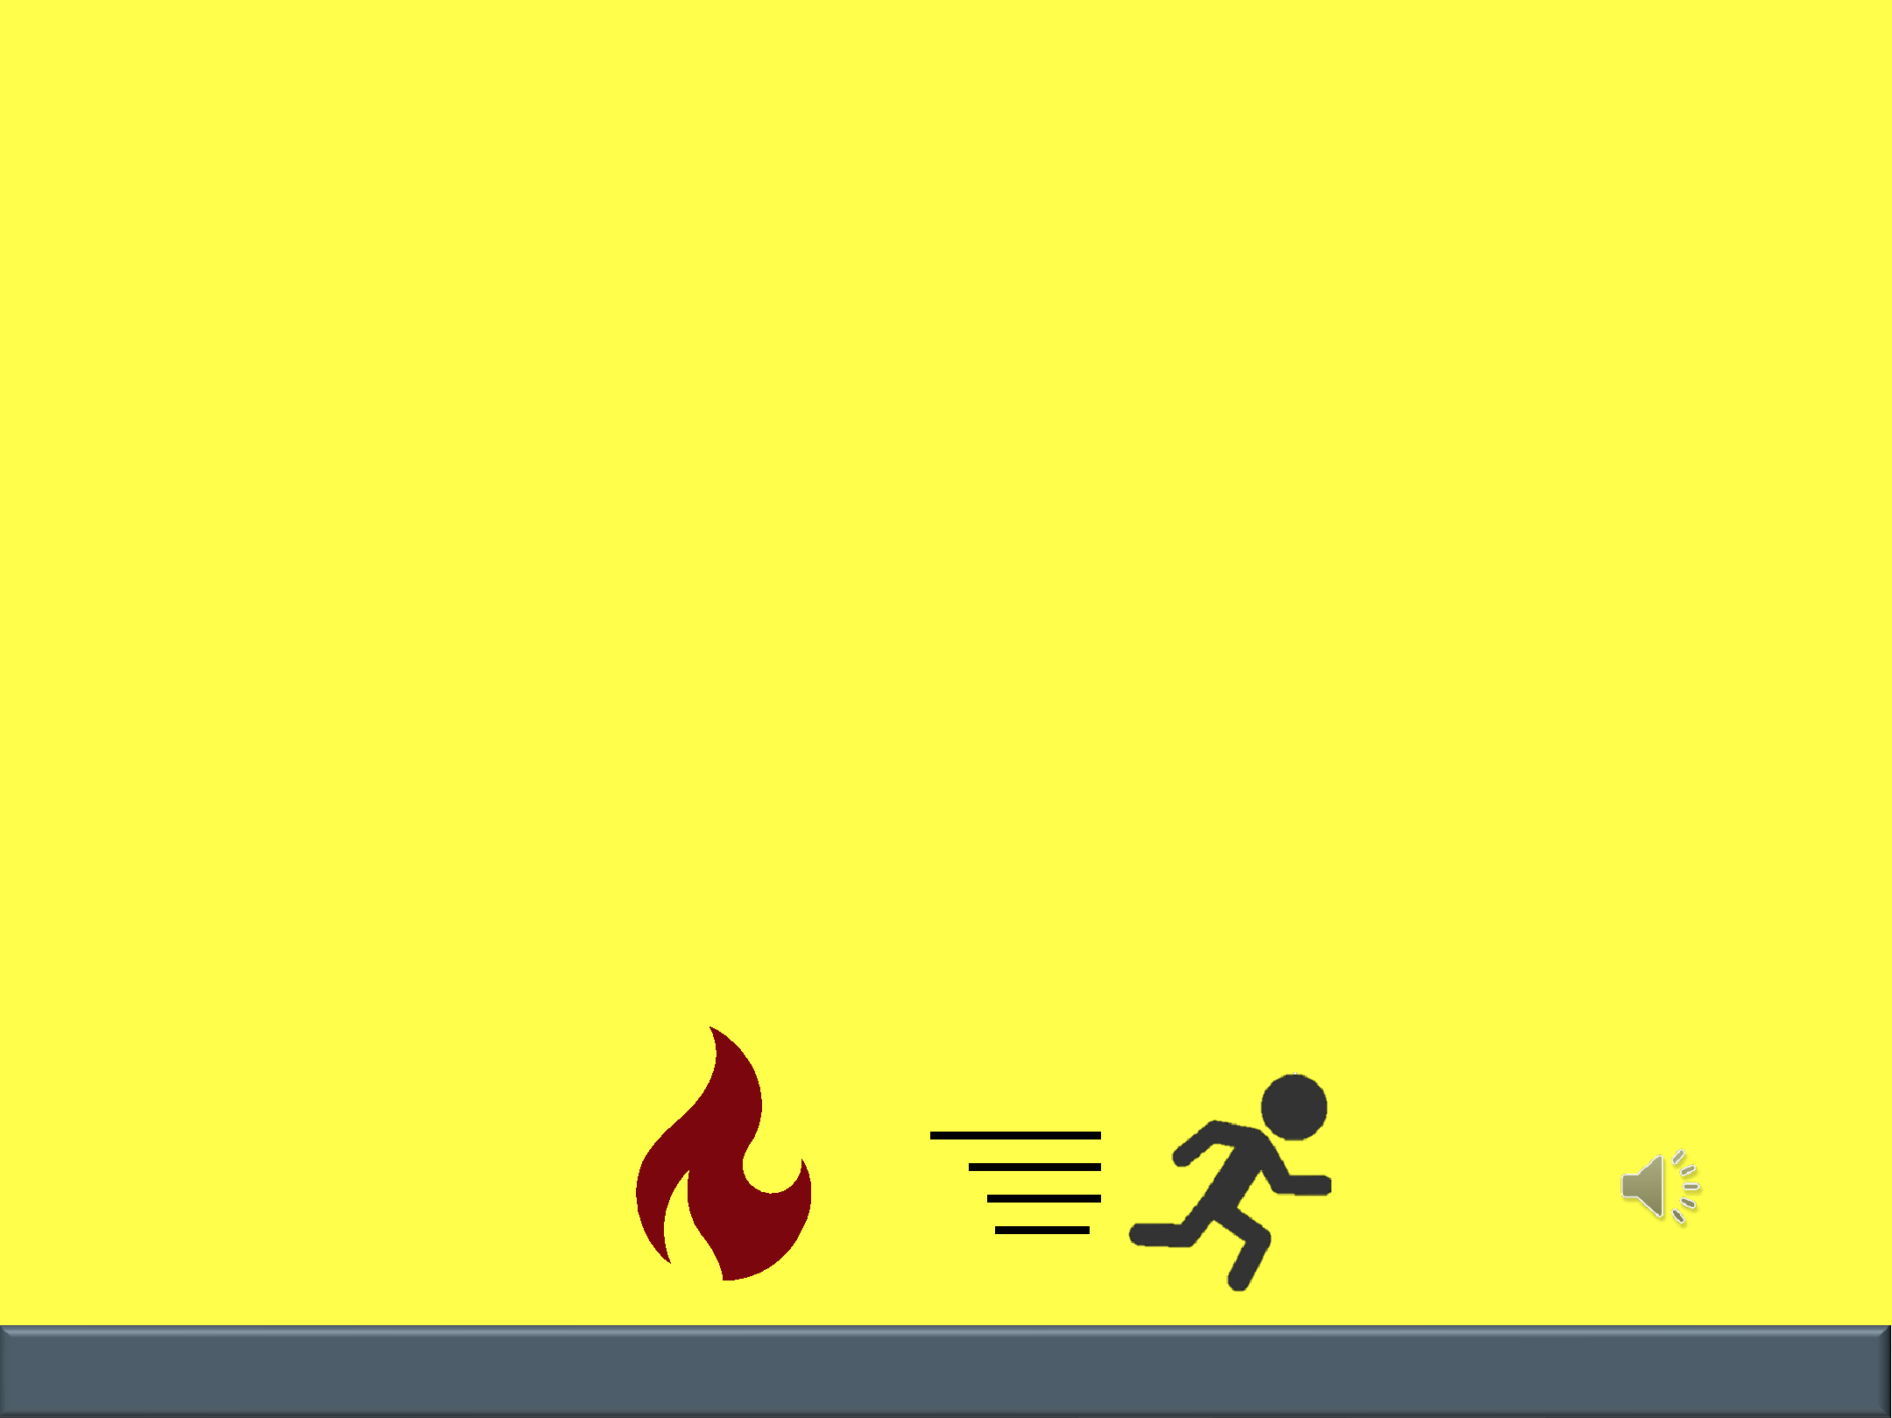
REMEMBER: FIRE MOVES FAST!

LEAVE IMMEDIATELY IF YOU FEEL UNSAFE!

DON’T WAIT FOR AN ALERT!

COMMUNICATION | COLLABORATION | COORDINATION | COOPERATION

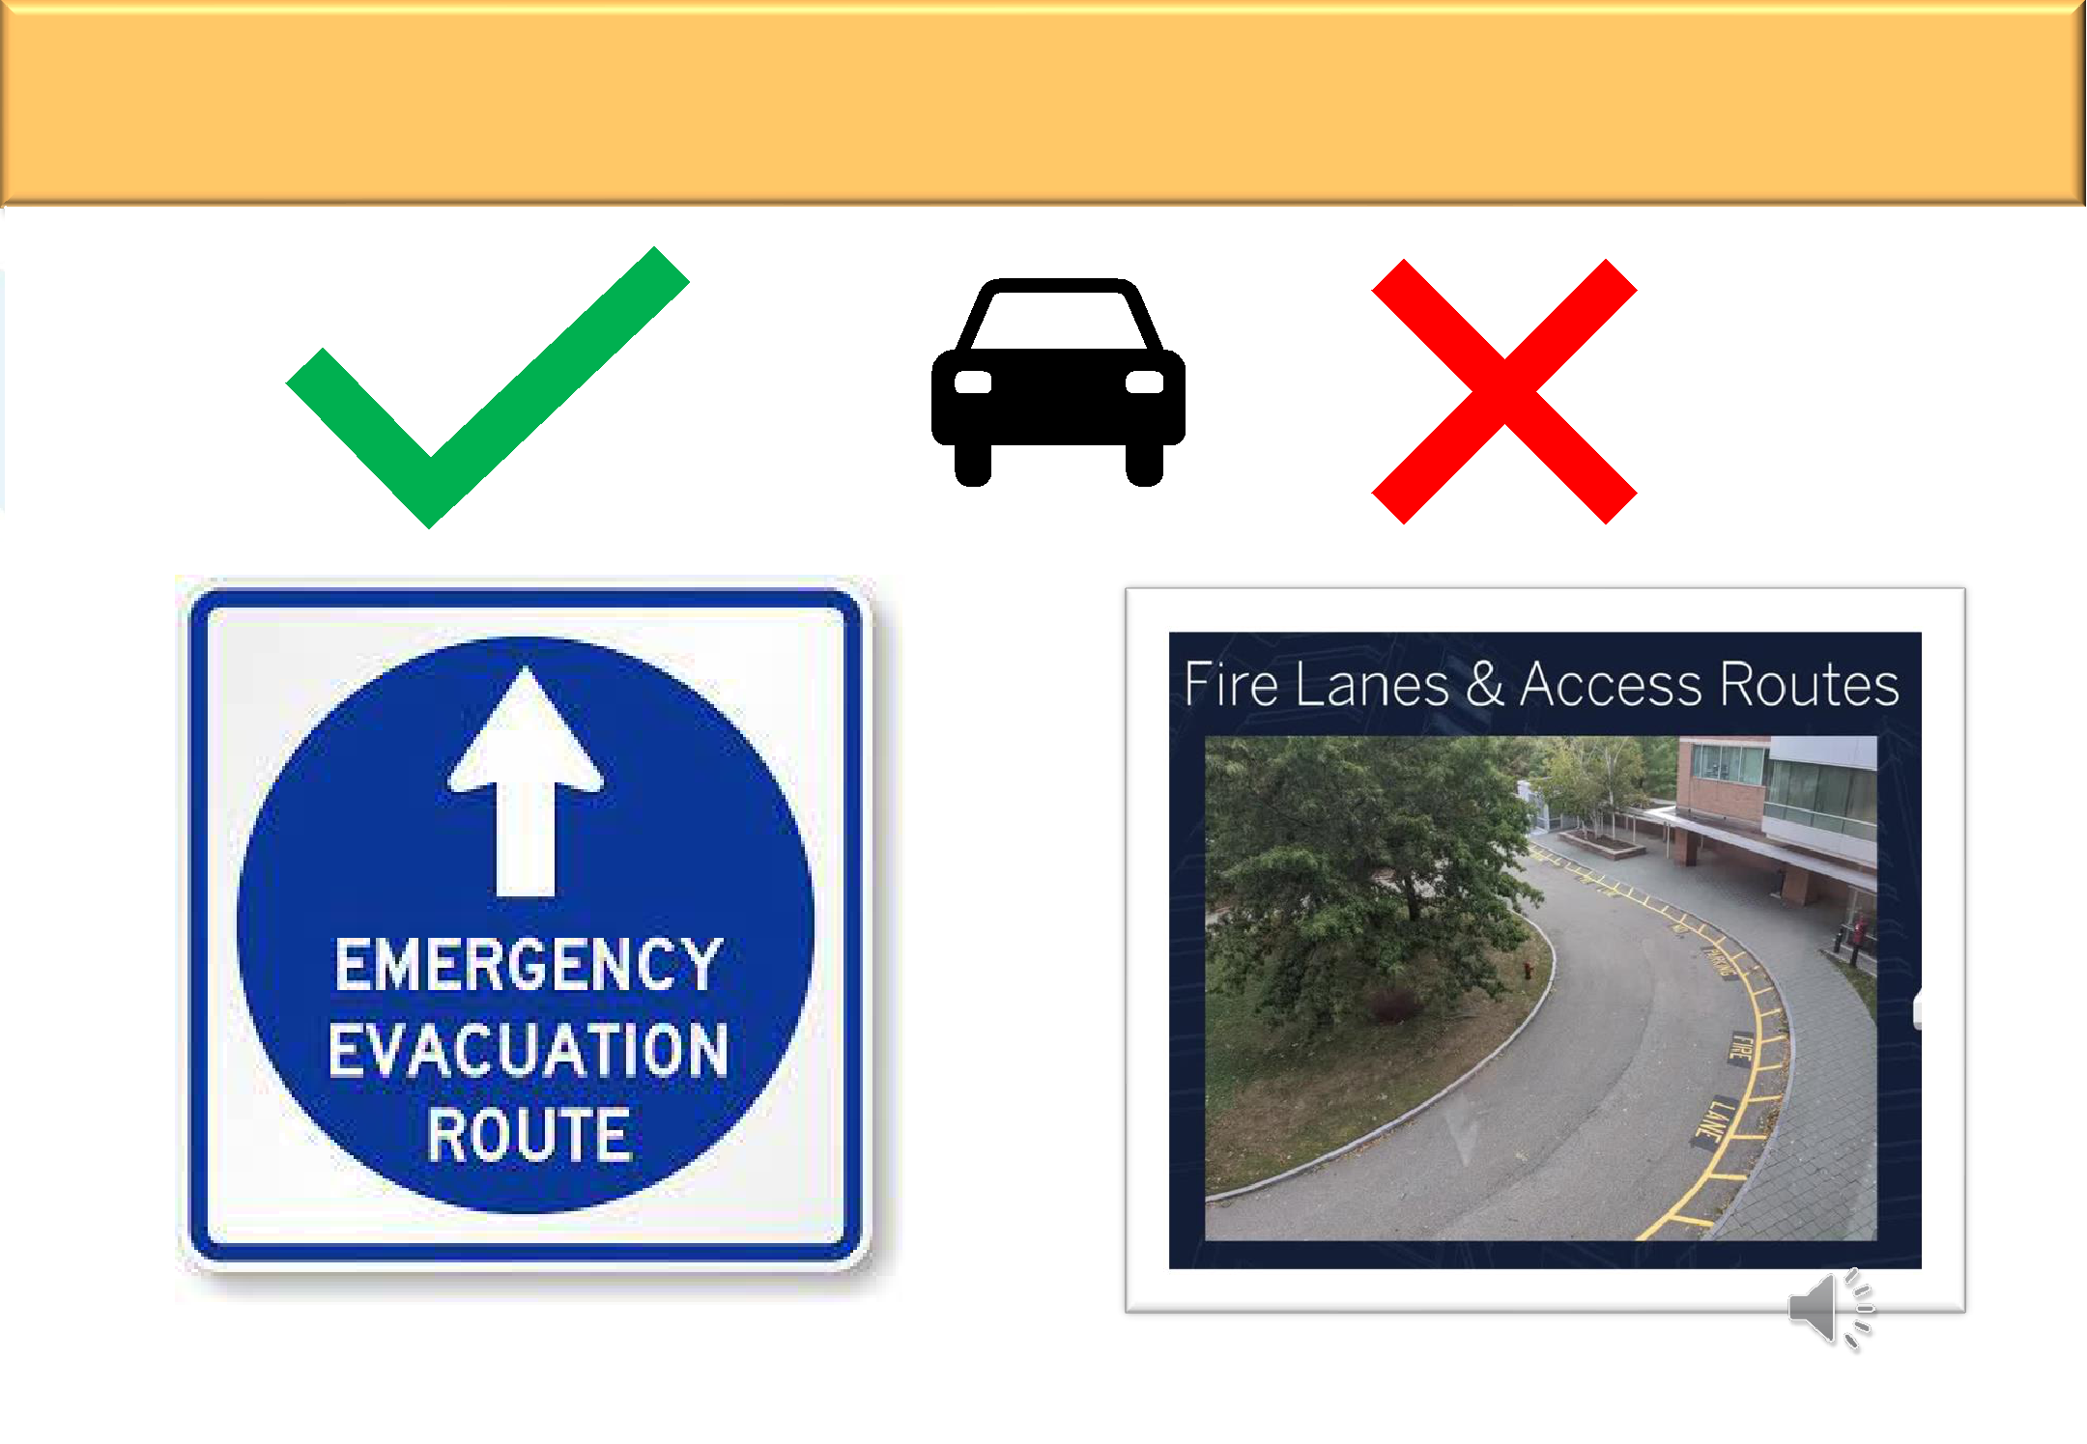
EVACUATE SAFELY

COMMUNICATION | COLLABORATION | COORDINATION | COOPERATION

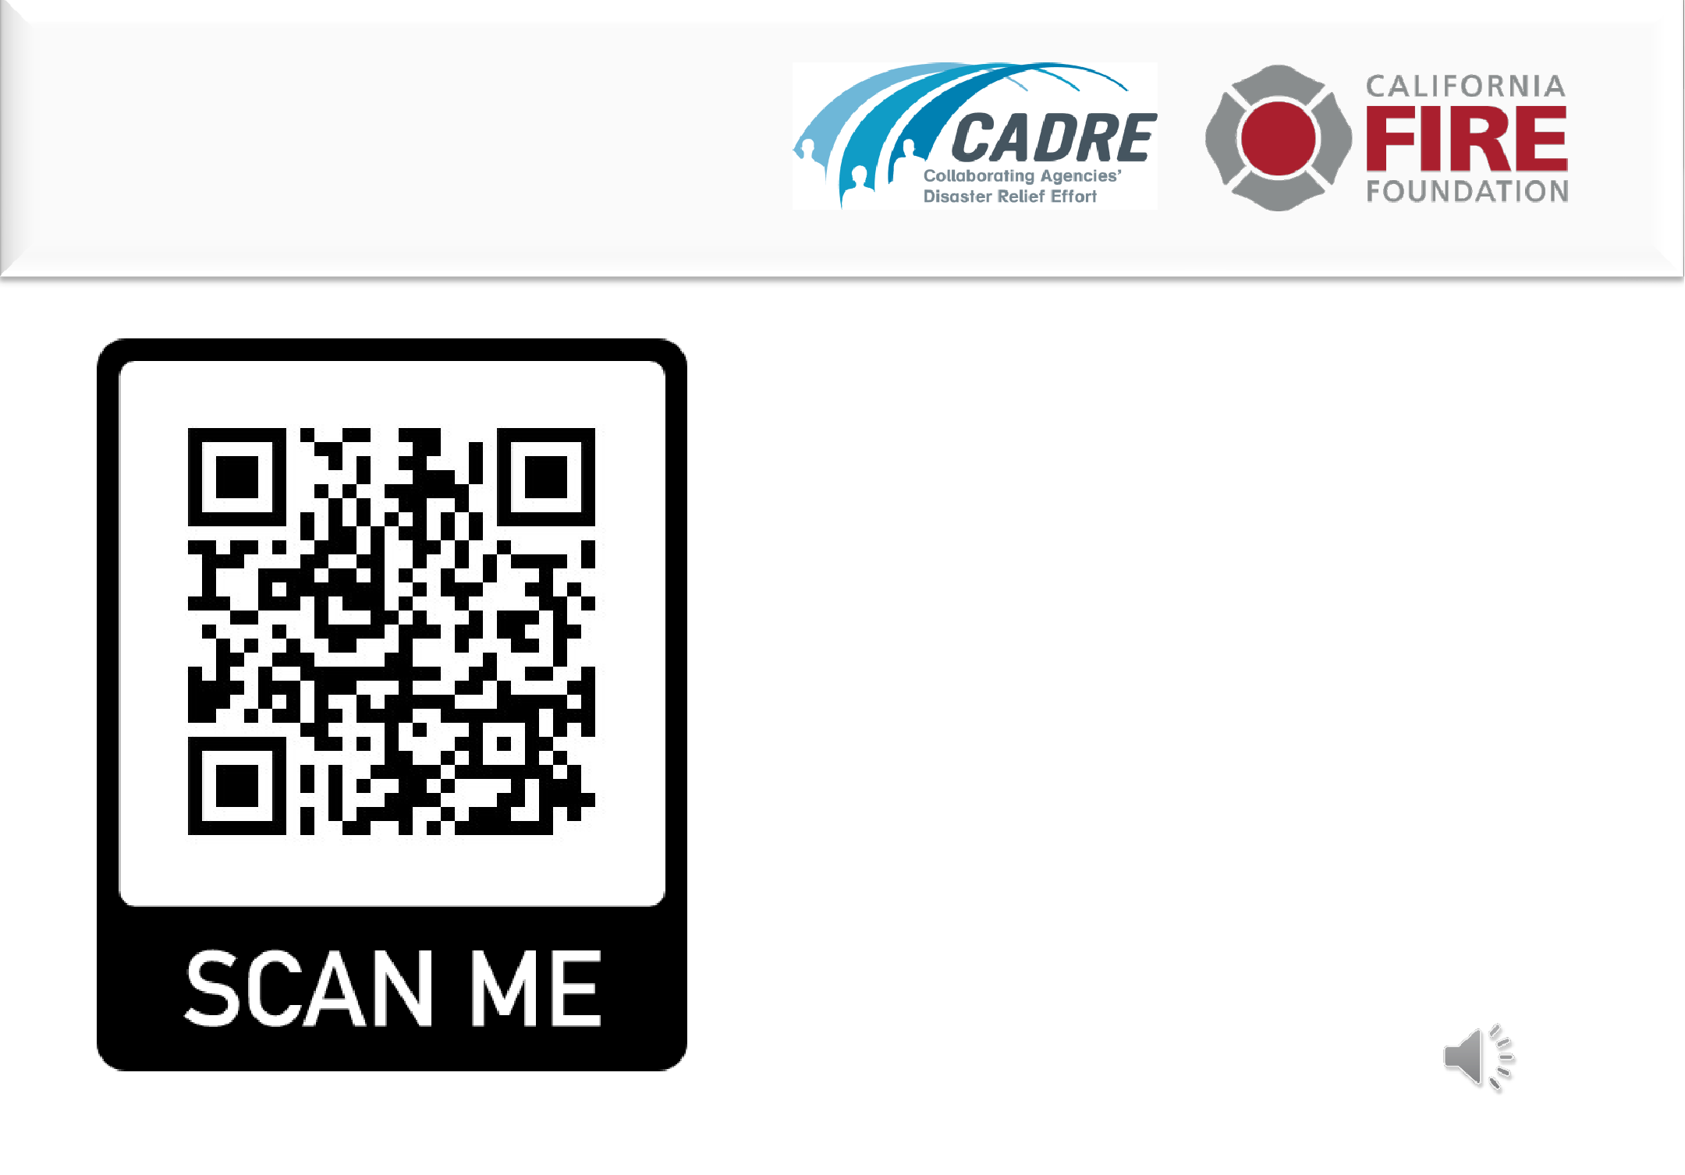
Brought to you by:

Learn more:

www.cadresv

.org/wildfire

COMMUNICATION | COLLABORATION | COORDINATION | COOPERATION

